<https://www.youtube.com/watch?v=OtD8wVaFm6E&list=PLblh5JKOoLUICTaGLRoHQDuF_7q2GfuJF&index=59>





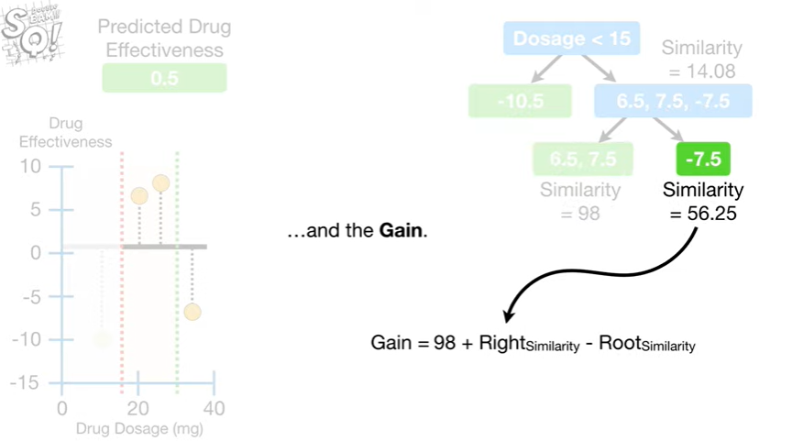

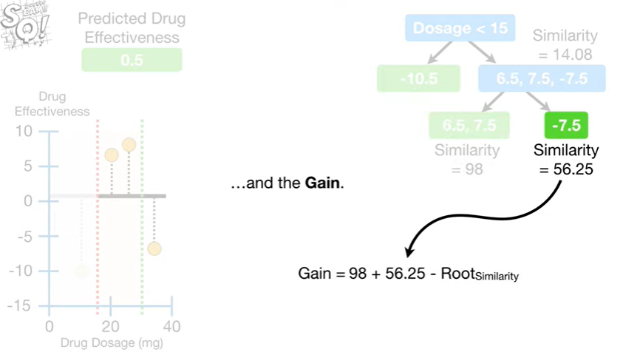

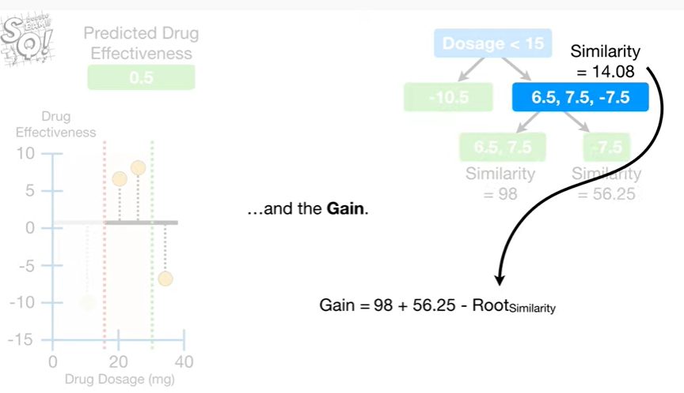

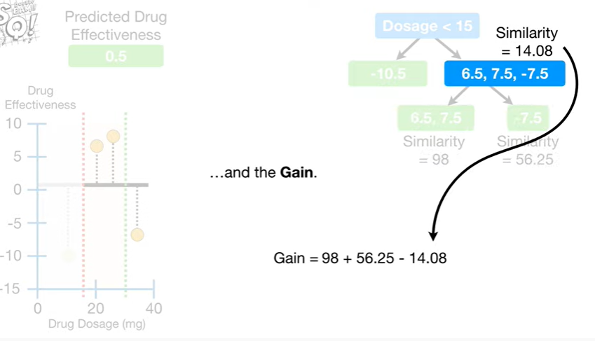

and the gain.

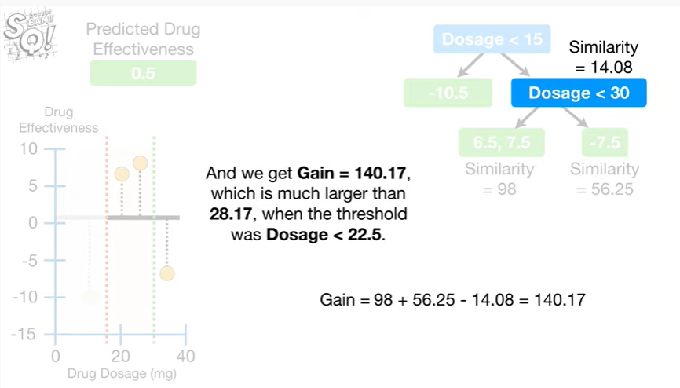

And we get gain equals one hundred forty point one seven which is much larger than twenty eight point one seven when the threshold was dosage less than twenty two point five.

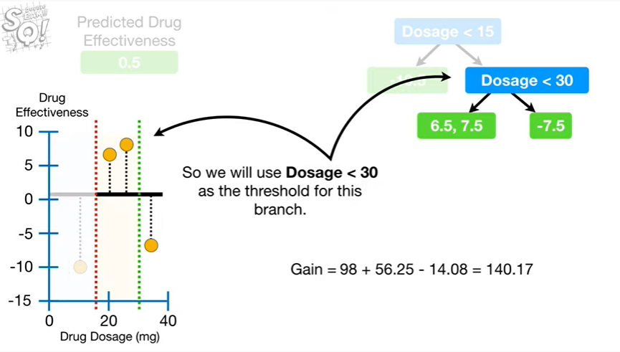

So we will use dosage less than 30 as the threshold for this branch.

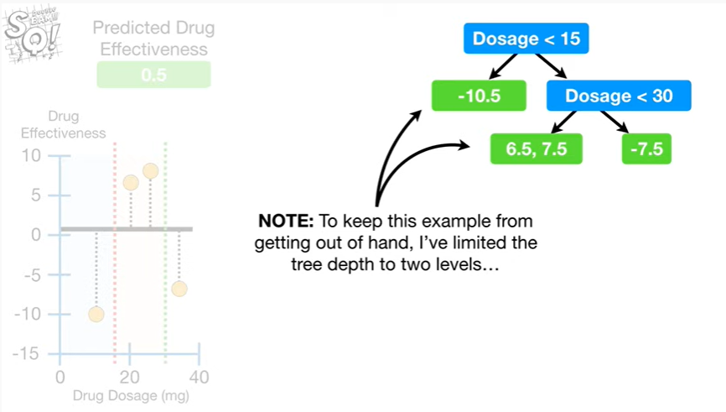

Note : to keep this example from getting out of hand I've limited the tree depth to two levels

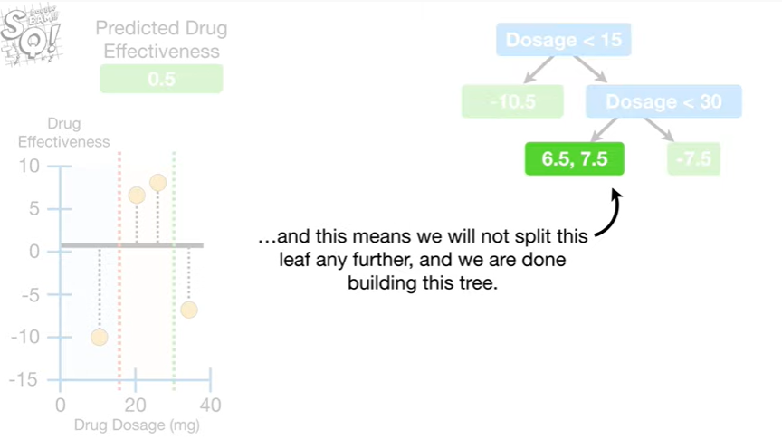

and this means we will not split this leaf any further and we are done building this tree.

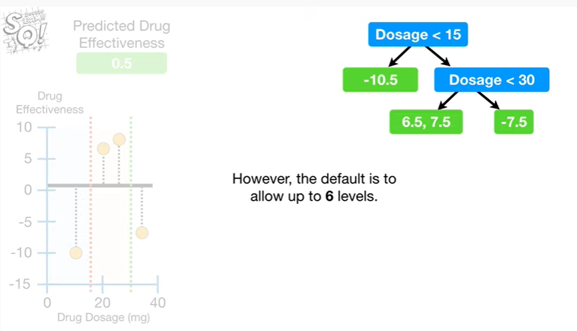

However, the default is to allow up to six levels.

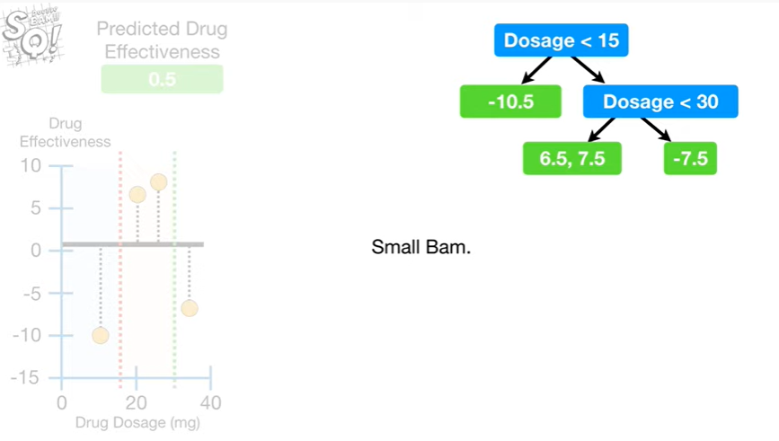

Small BAM.

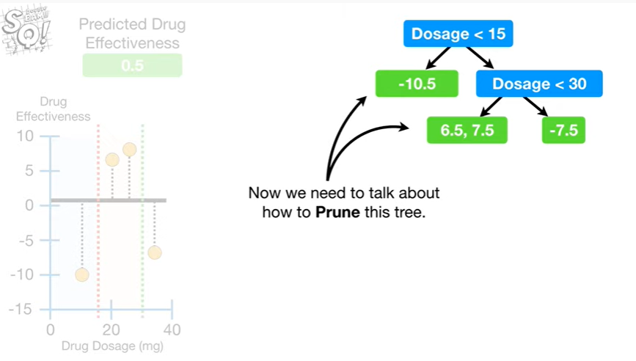

Now we need to talk about how to prune this tree.

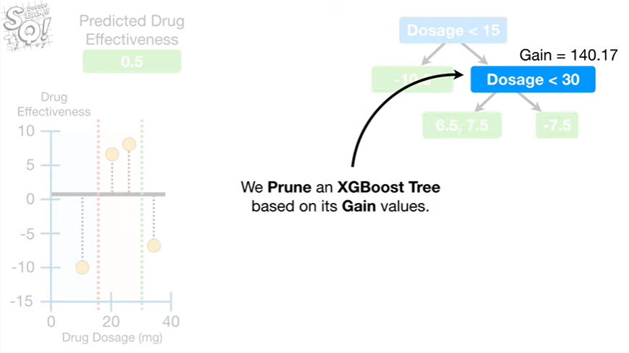

We prune an XGBoost tree based on its gain values.

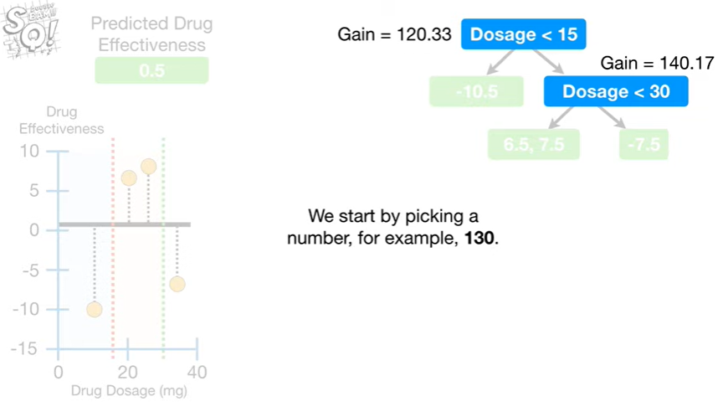

We start by picking a number, for example, 130.

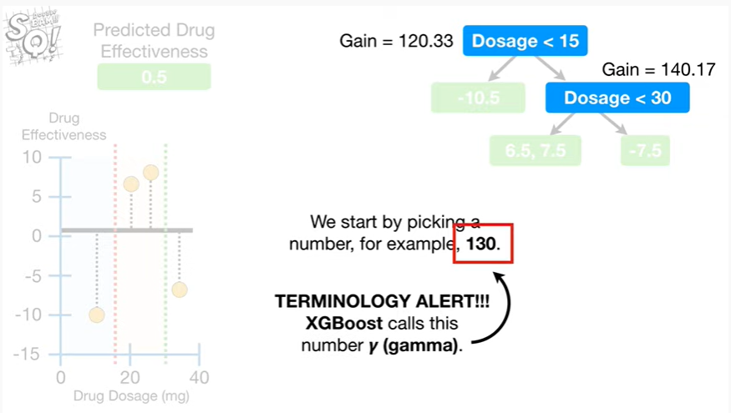

Oh no it's the dreaded terminology alert.

XGBoost calls this number gamma.

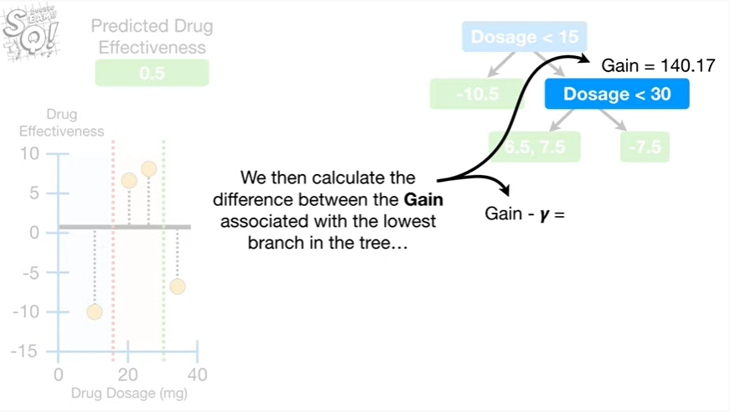

We then calculate the difference between the gain associated with the lowest branch in the tree

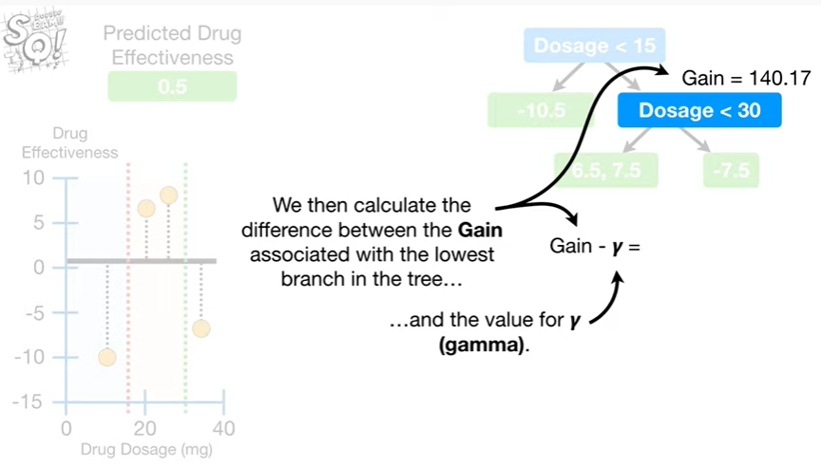

and the value for gamma.

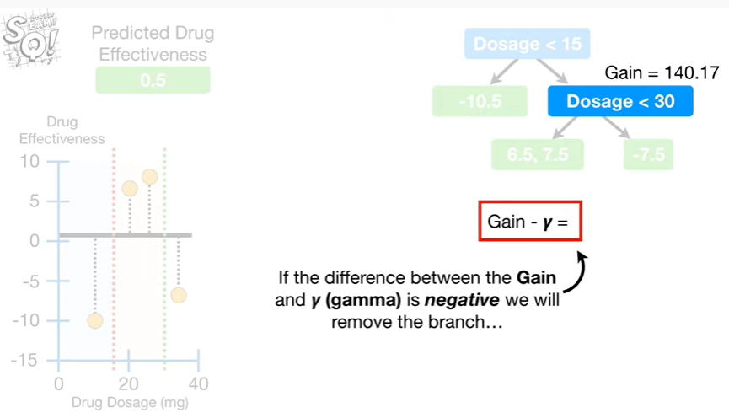

If the difference between the gain and gamma is negative we will remove the branch

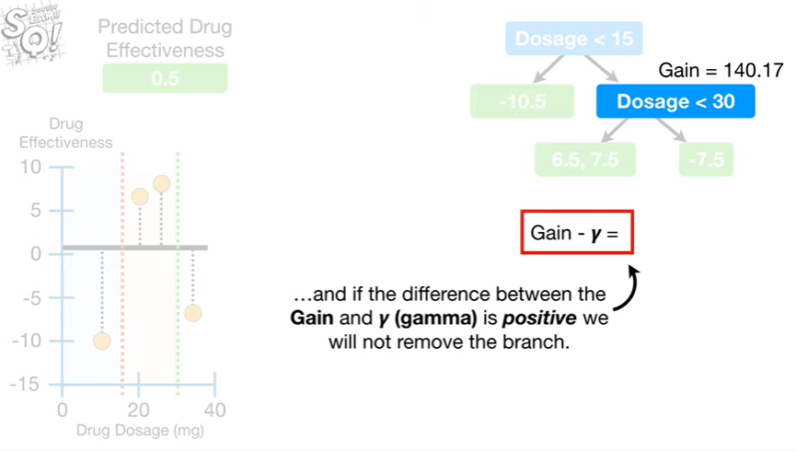

and if the difference between the gain and gamma is positive we will not remove the branch.

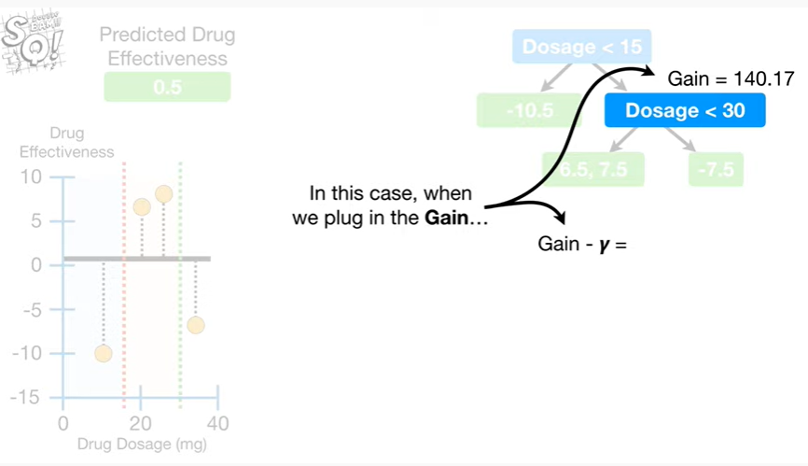

In this case, when we plug in the gain

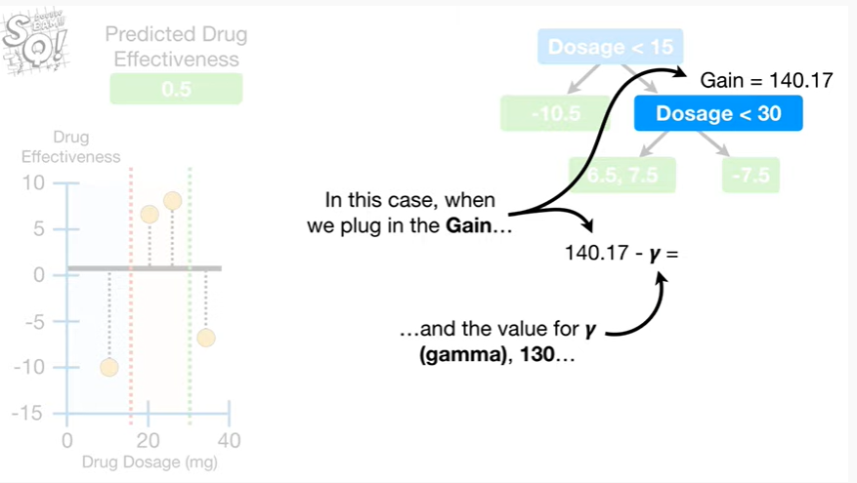

and the value for gamma 130

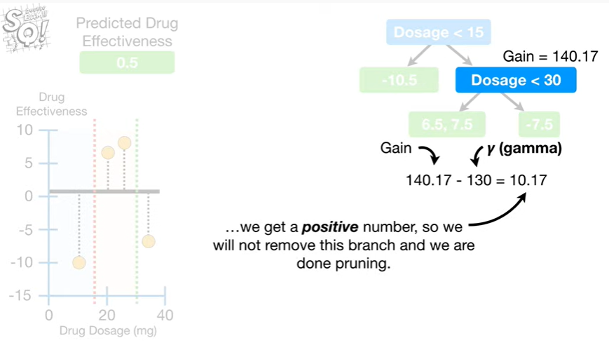

we get a positive number, so we will not remove this branch and we are done pruning.

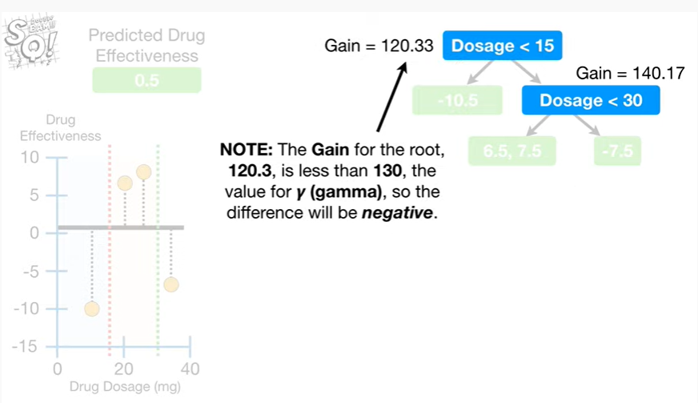

Note : the gain for the route 120 point three is less than 130, the value for gamma, so the difference will be negative.

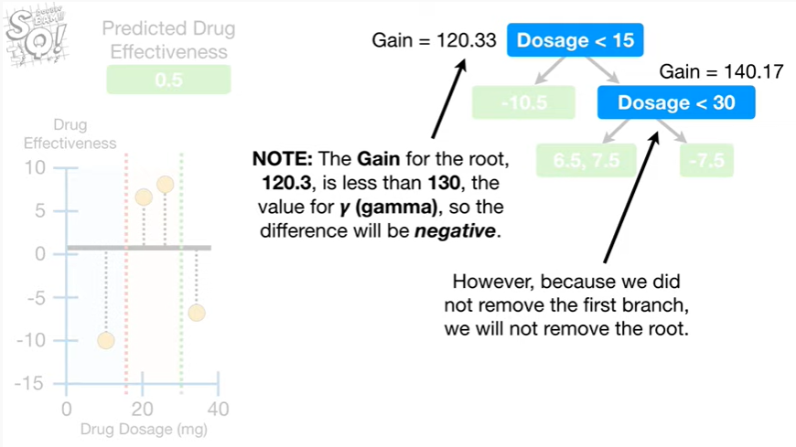

However, because we did not remove the first branch, we will not remove the root.

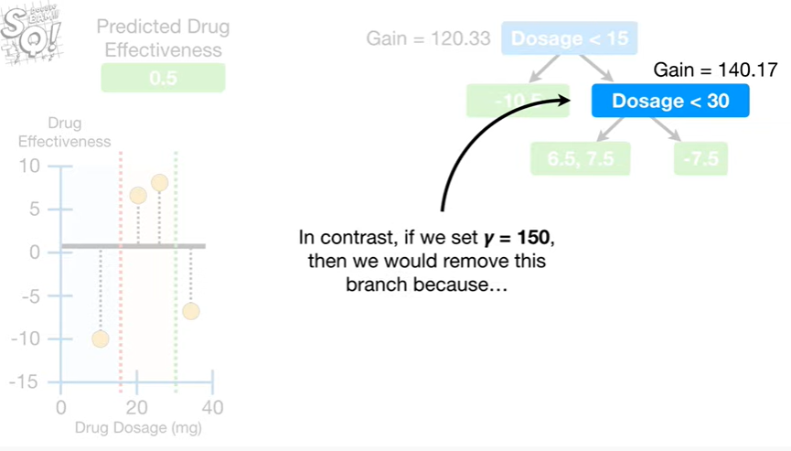

In contrast if we set gamma equal to 150, then we would remove this branch because

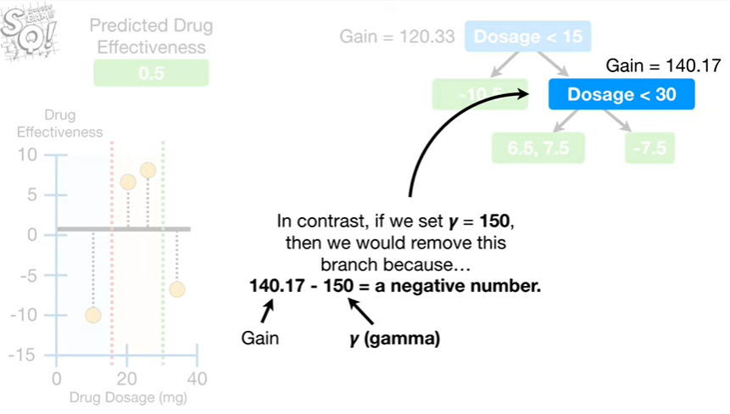

140 point 1 7 minus 150 equals a negative number.

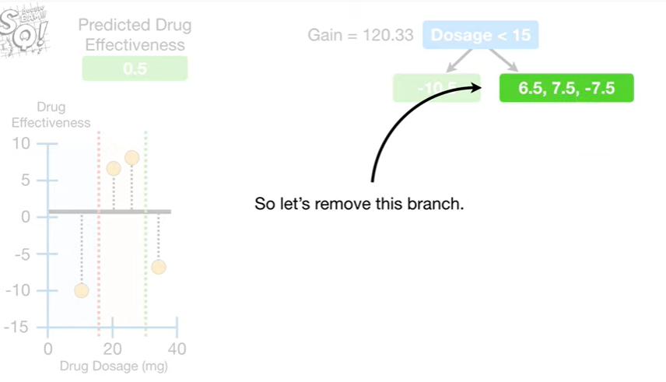

So let's remove this branch.

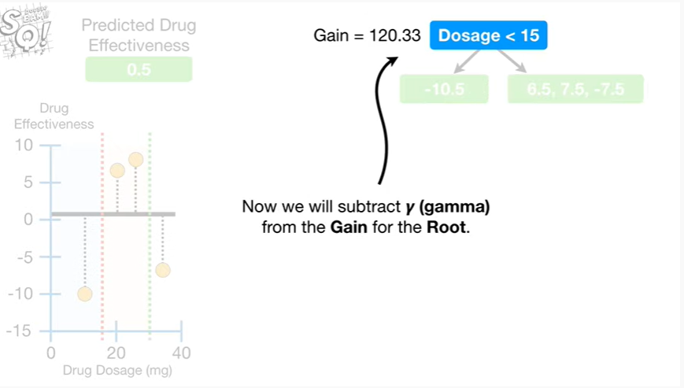

Now we subtract gamma from the gain for the root.

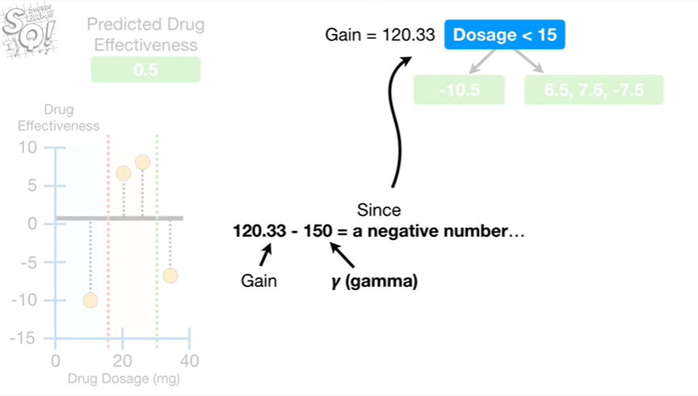

Since 120 point 3 3 minus 150 equals a negative number

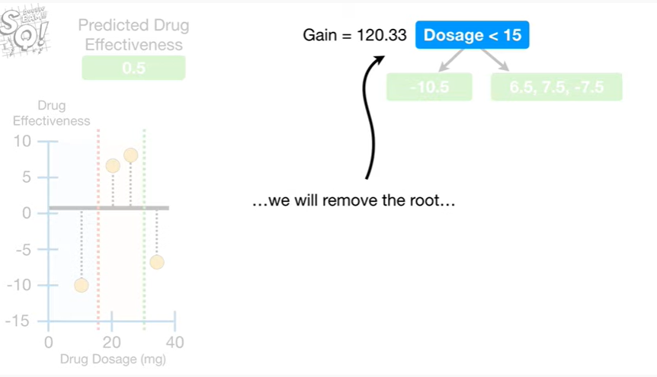

we will remove the root

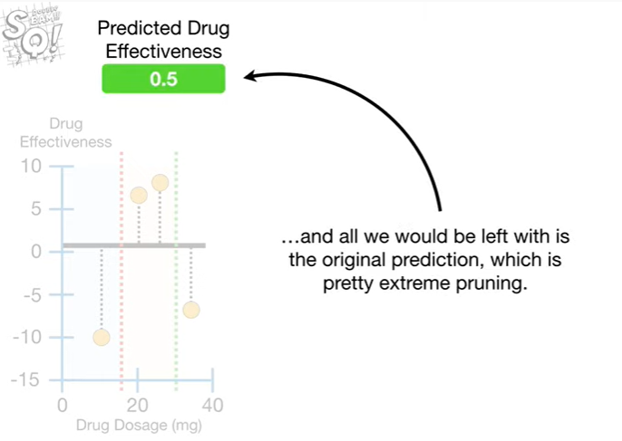

and all we would be left with is the original prediction which is pretty extreme pruning.

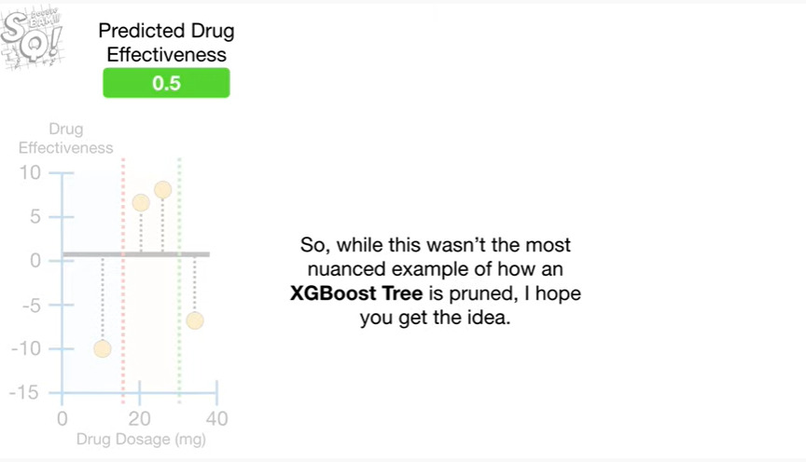

So, while this wasn't the most nuanced example of how an X G boost tree is pruned, I hope you get the idea.

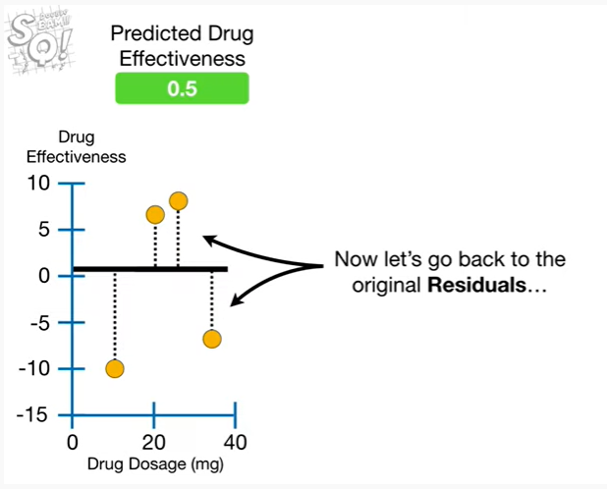

Now let's go back to the original residuals

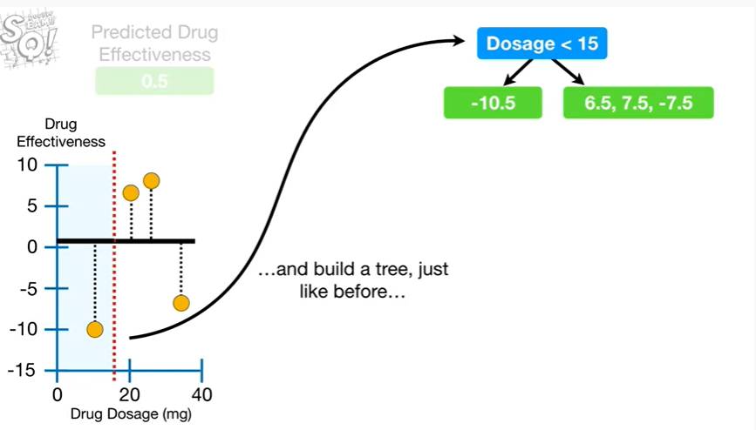

and build a tree, just like before

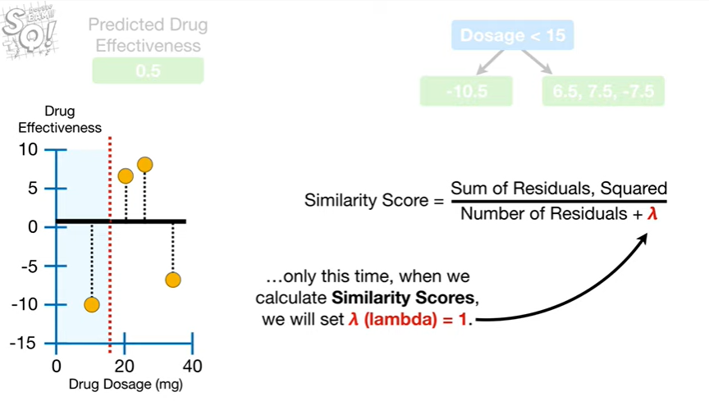

only this time, when we calculate similarity scores we will set lambda equal to one.

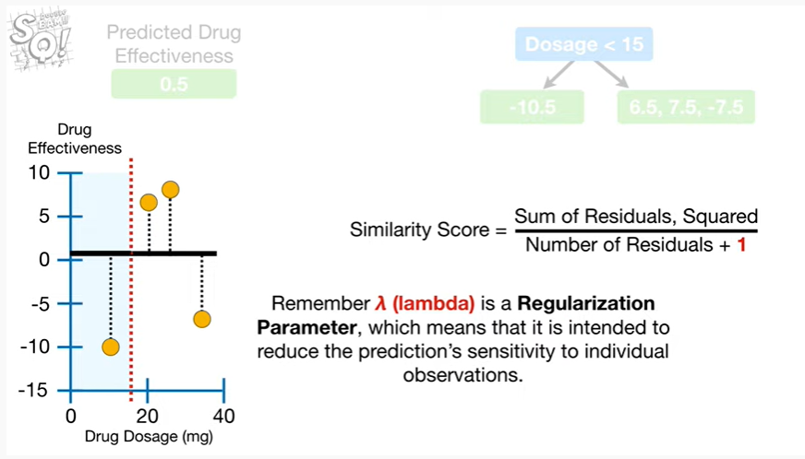

Remember lambda is a regularization parameter, which means that it is intended to reduce the prediction sensitivity to individual observations.

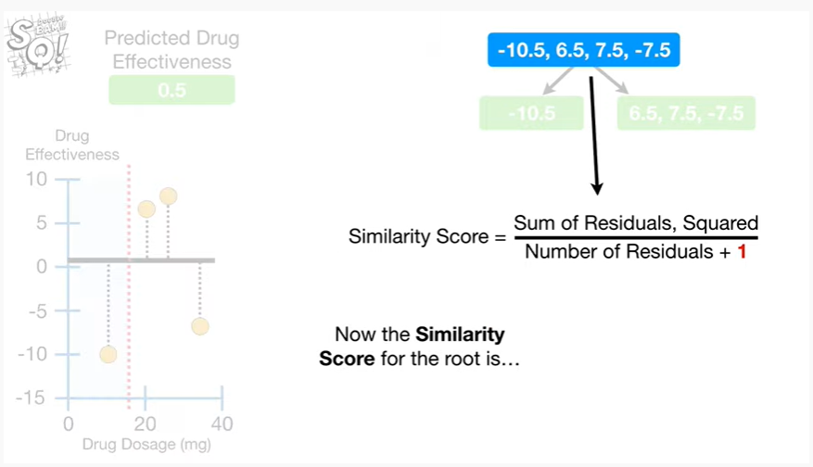

Now the similarity score for the root is

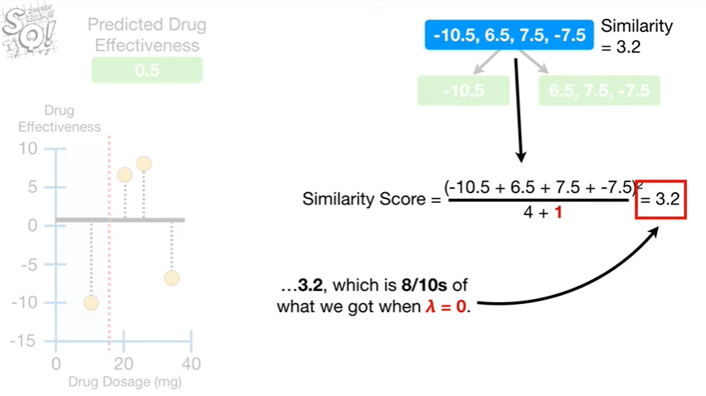

3.2 which is 8/10 of what we got when lambda equals 0.

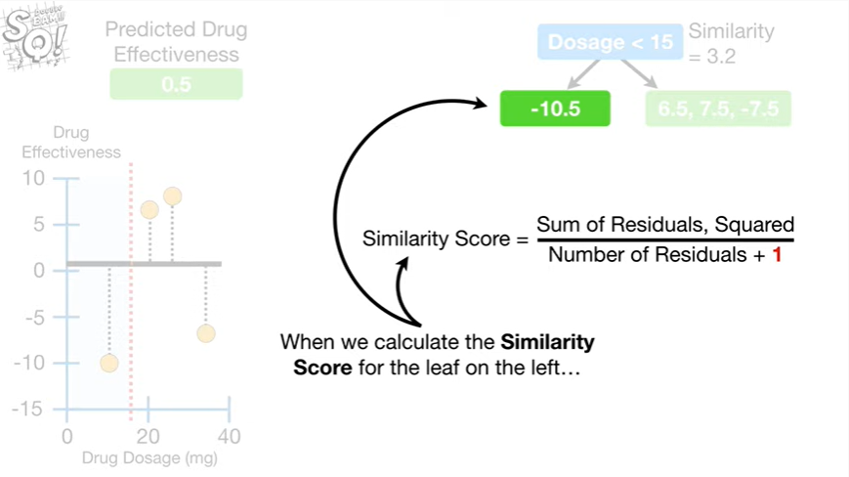

When we calculate the similarity score for the leaf on the Left

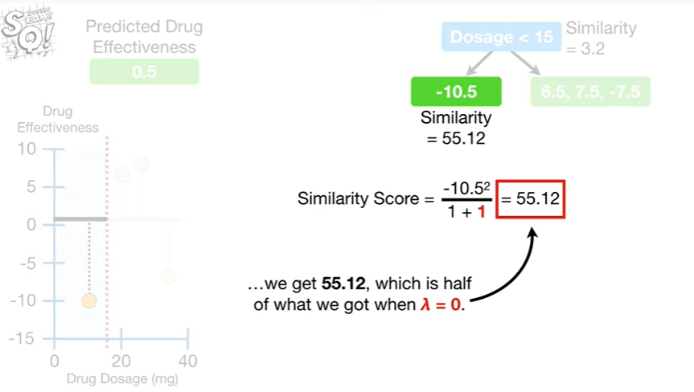

we get fifty five point one two, which is half of what we got when lambda equals zero.

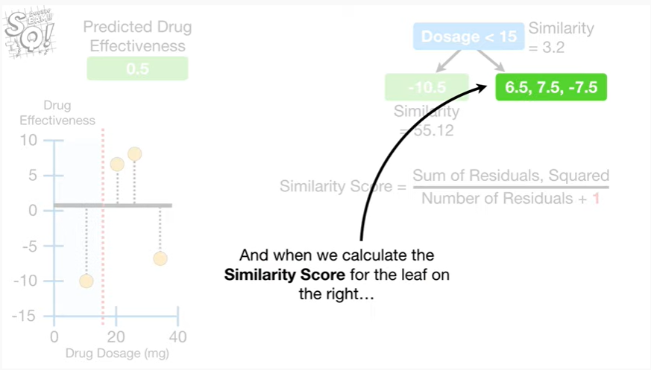

And when we calculate the similarity score for the leaf on the right

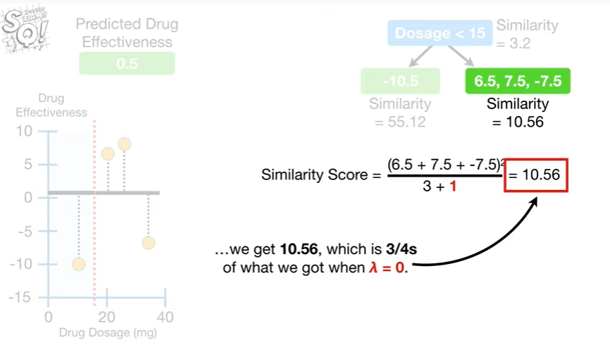

we get ten point five six, which is three-quarters of what we got when lambda equals zero.

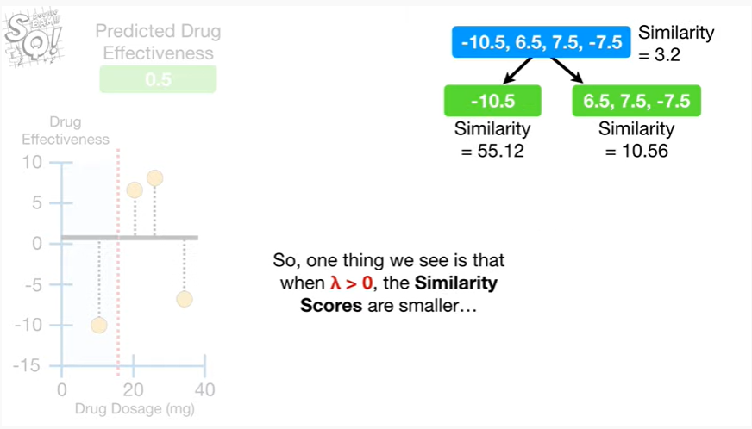

So, one thing we see is that when lambda is greater than zero, the similarity scores are smaller

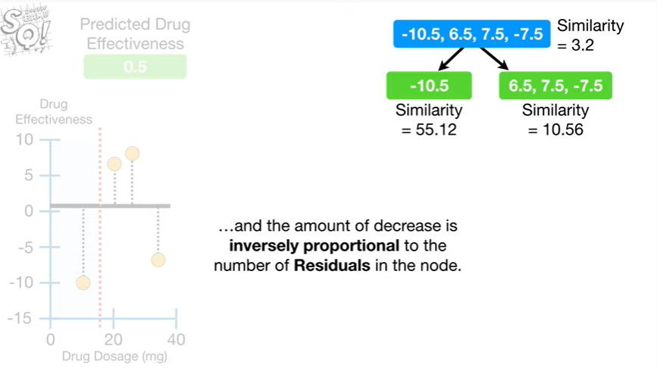

and the amount of decrease is inversely proportional to the number of residuals in the node.

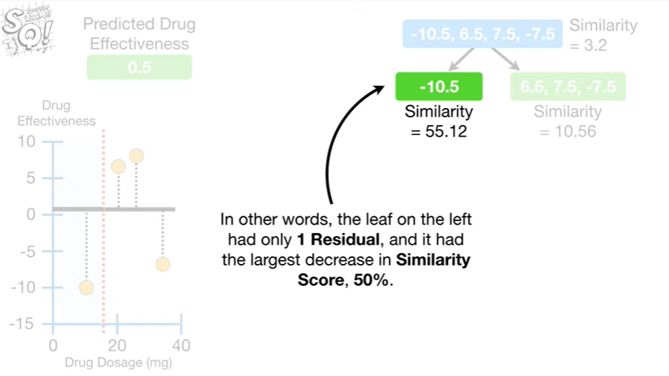

In other words, the leaf on the Left had only one residual, and it had the largest decrease in similarity score 50%.

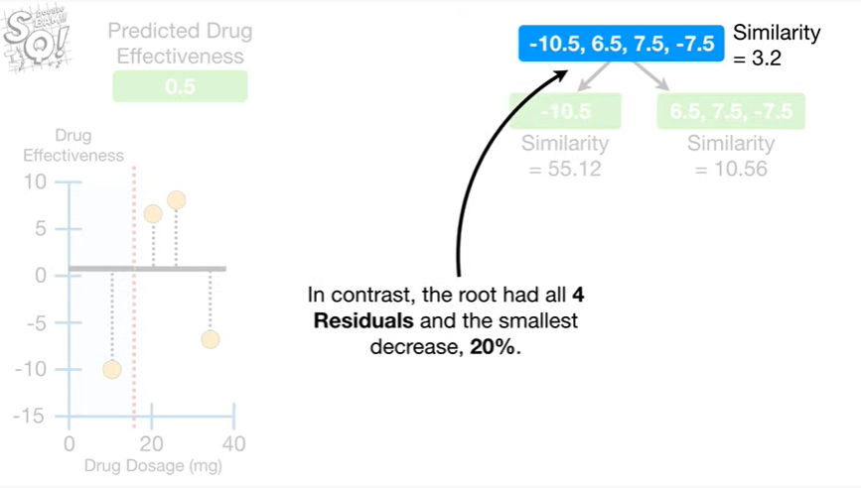

In contrast, the root had all four residuals in the smallest decrease, 20%.

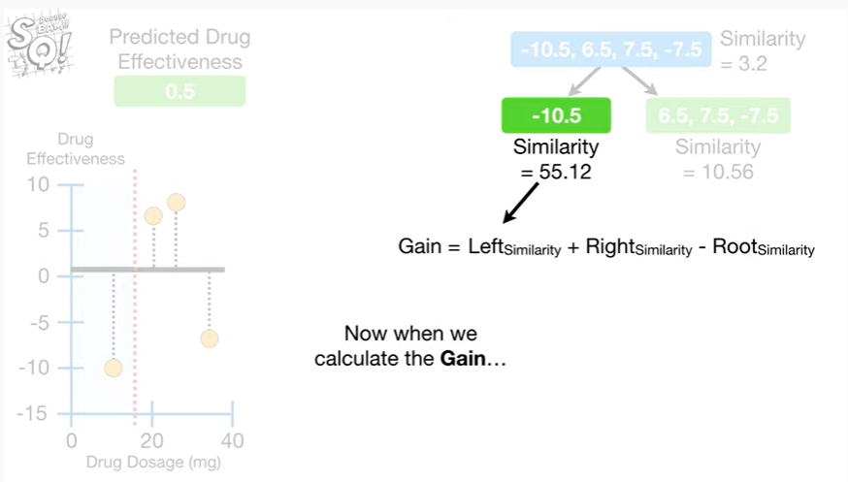

Now when we calculate the gain

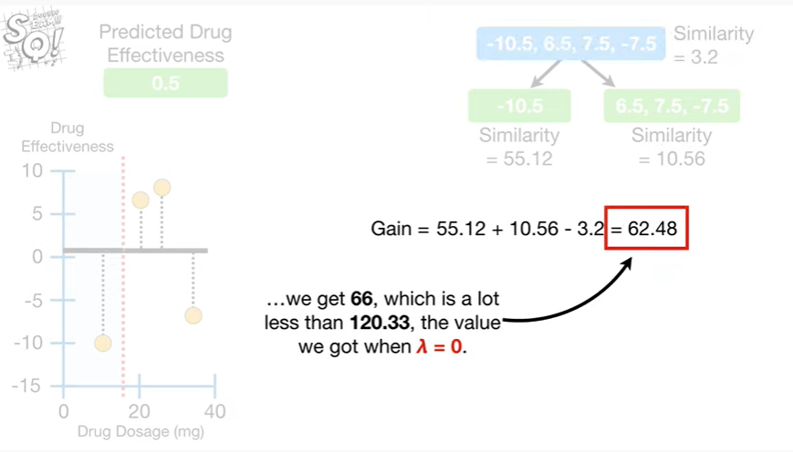

we get 66, which is a lot less than 120 point 3 3, the value weak out when lambda equals 0.

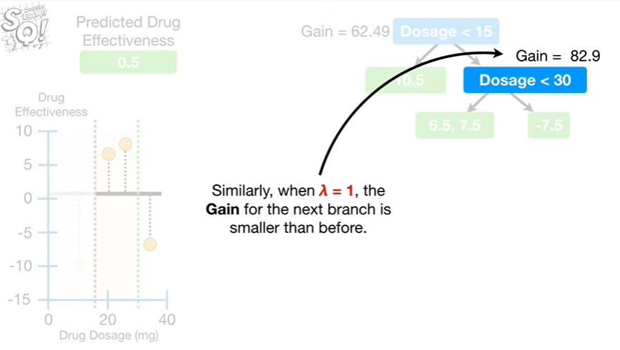

Similarly, when lambda equals one, the gain for the next branch is smaller than before.

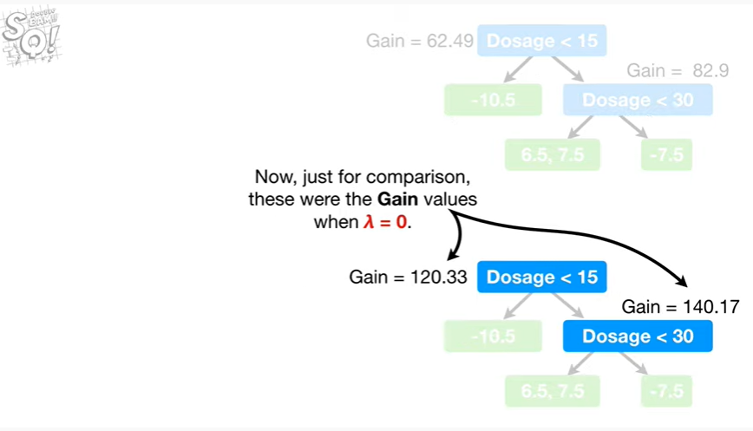

Now just for comparison these were the gain values when lambda equals zero.

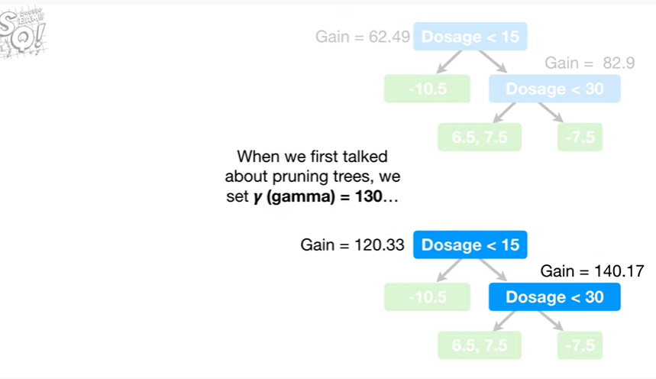

When we first talked about pruning trees, we set gamma equal to 130

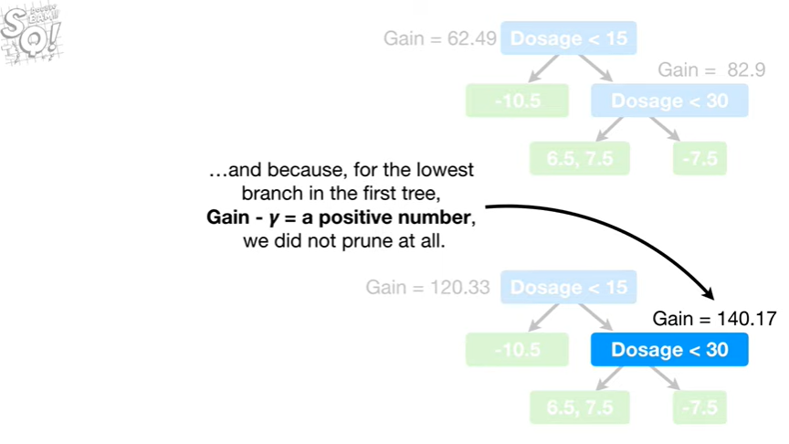

and because for the lowest branch in the first tree, gain minus gamma equaled a positive number so we did not prune at all.

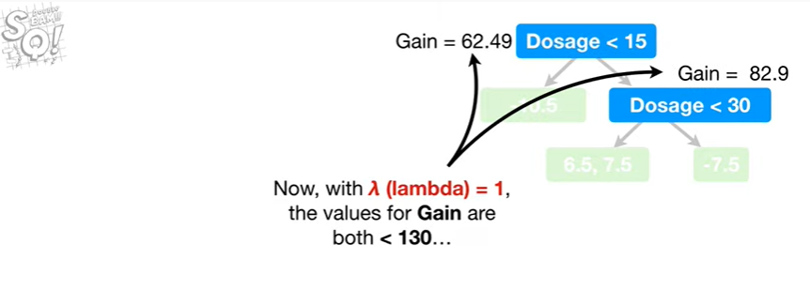

Now with lambda equals 1, the values for gain are both less than 130.

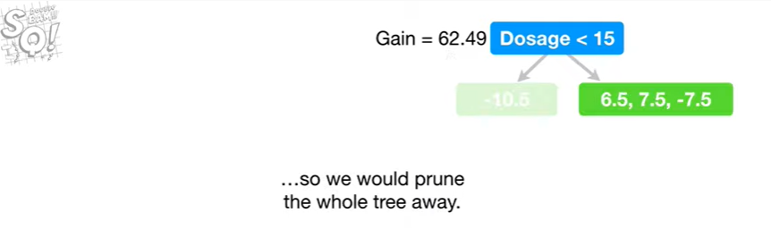

So we would prune the whole tree away.

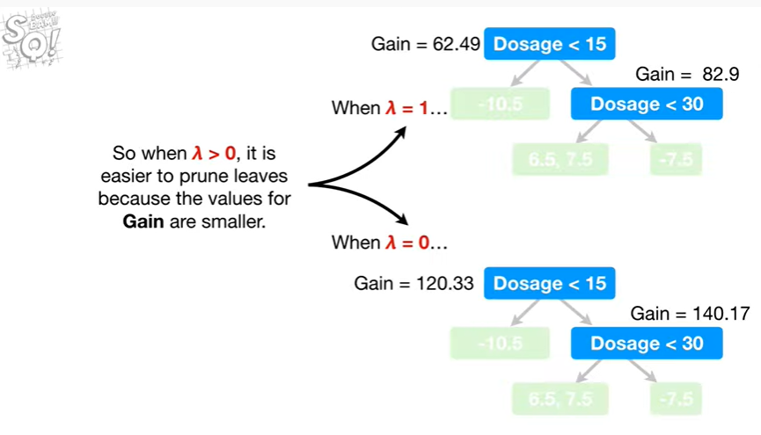

So when lambda is greater than zero, it is easier to prune leaves because the values for gain are smaller.

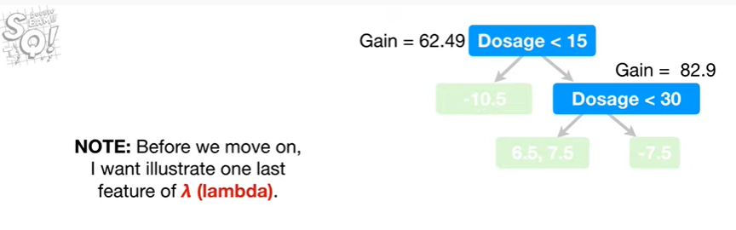

Note : before we move on I want to illustrate one last feature of lambda.

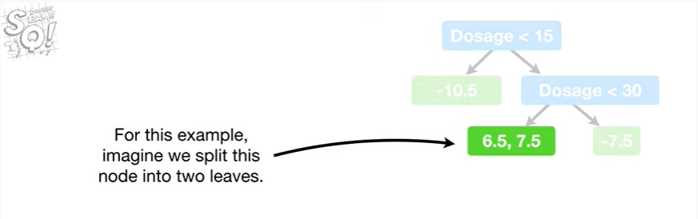

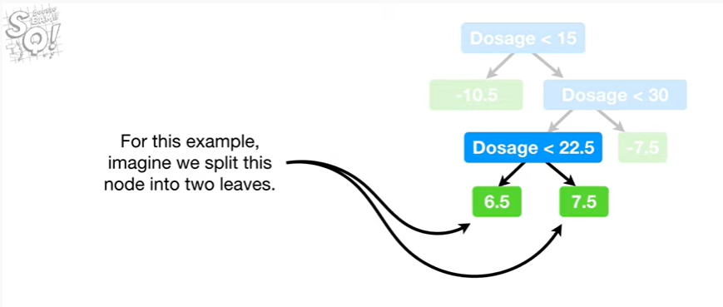

For this example, imagine we split this node into two leaves.

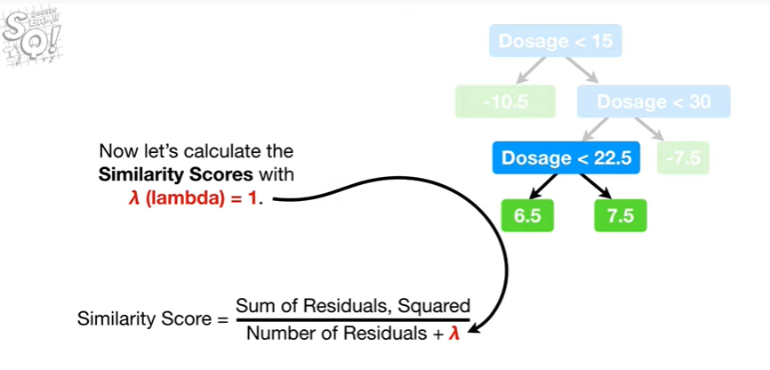

Now let's calculate the similarity scores with lambda equal to one.

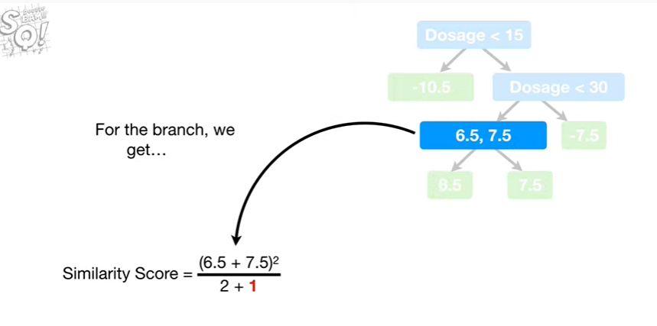

For the branch we get

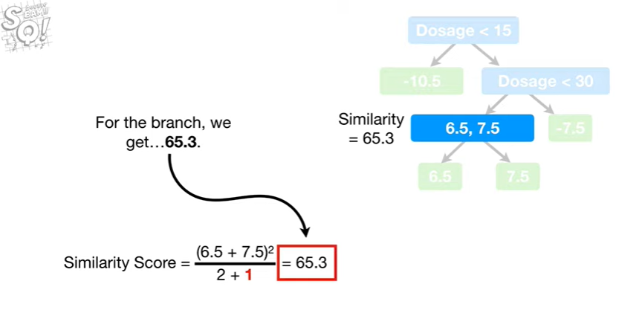

sixty five point three.

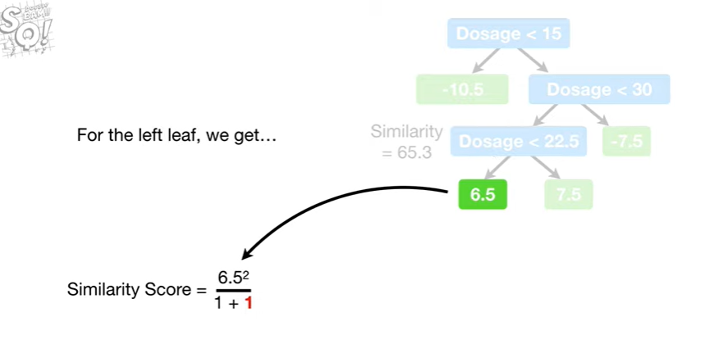

For the left leaf, we get

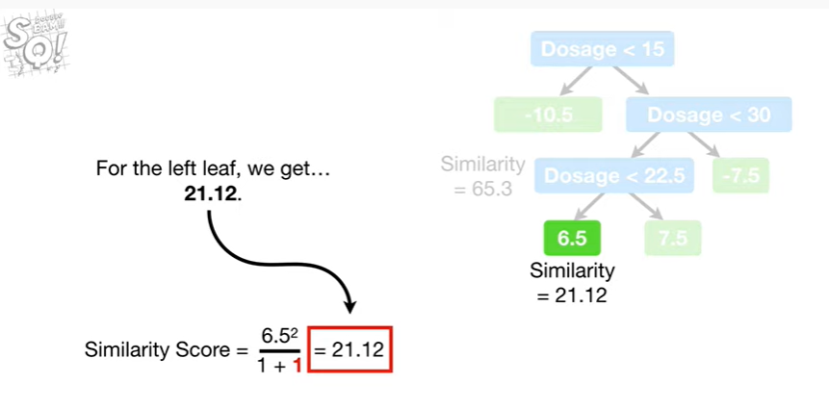

twenty one point one two.

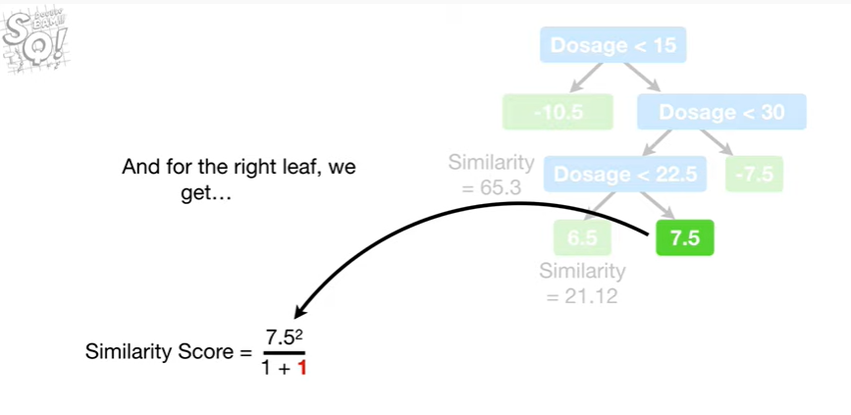

And for the right leaf we get

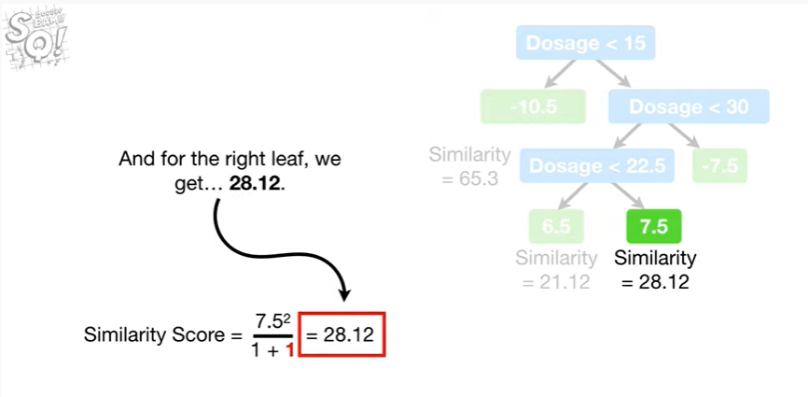

28.12

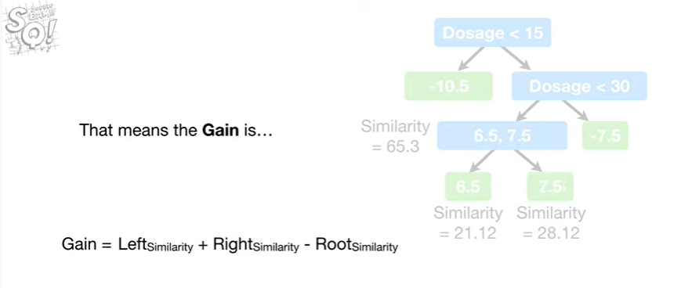

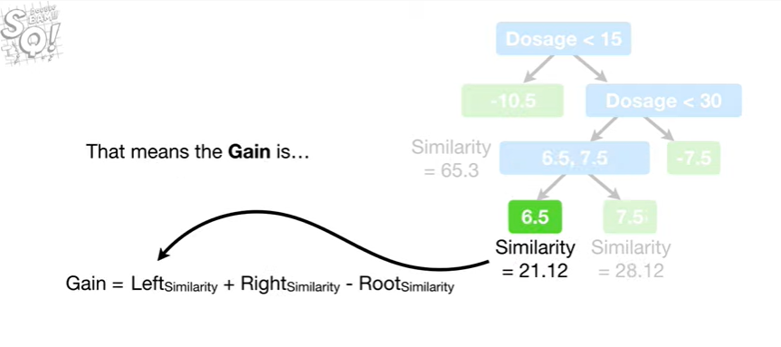

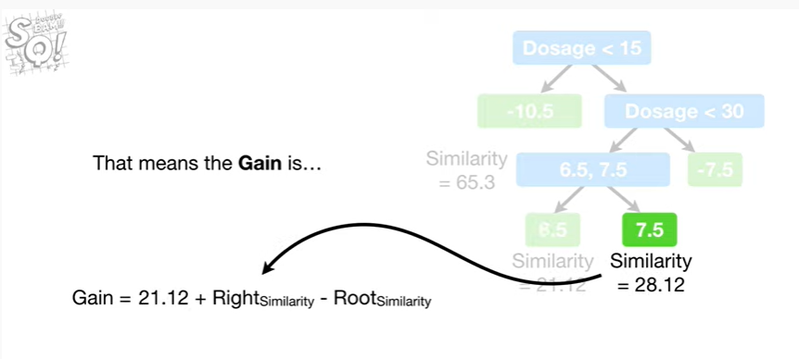

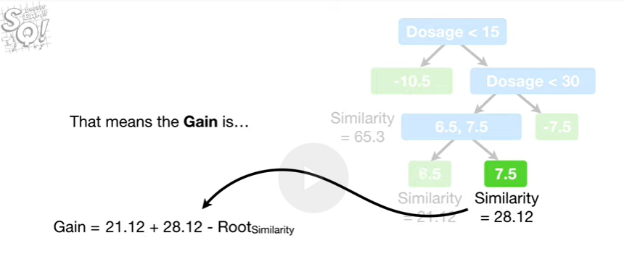

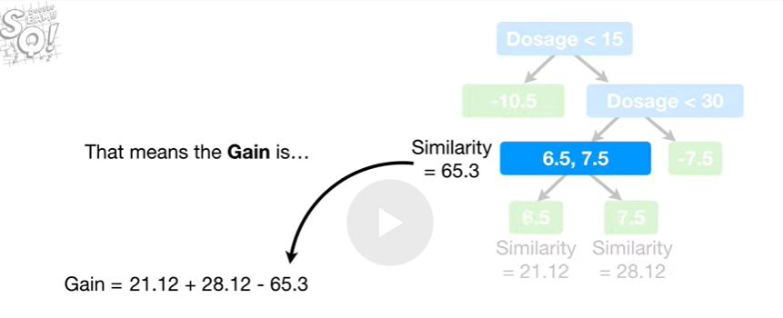

That means the gain is

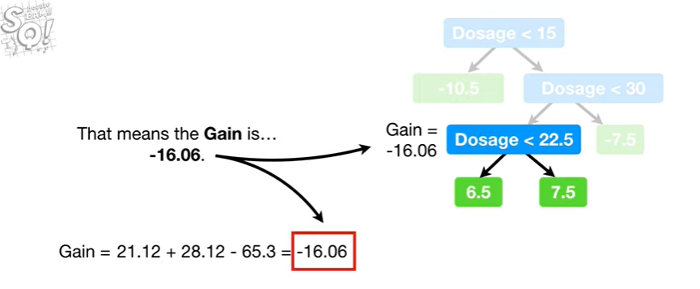

negative sixteen point zero six.

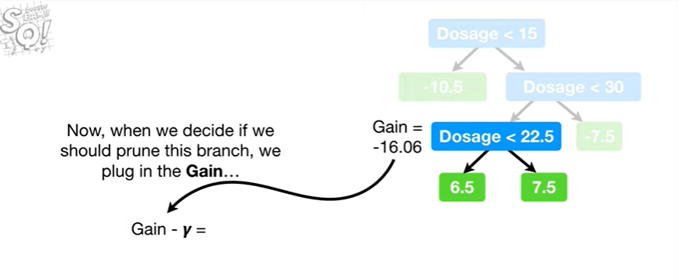

Now when we decide if we should prune this branch, we plug in the gain

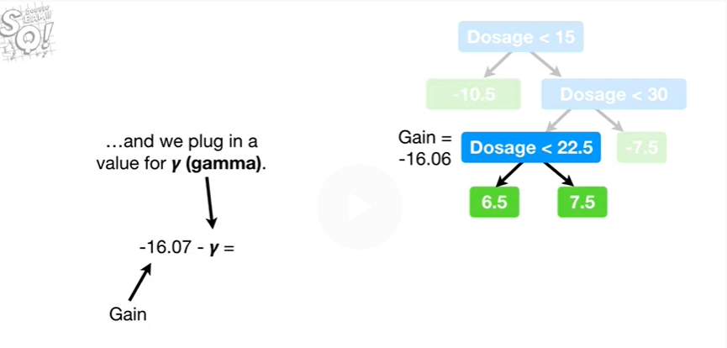

and we plug in a value for gamma.

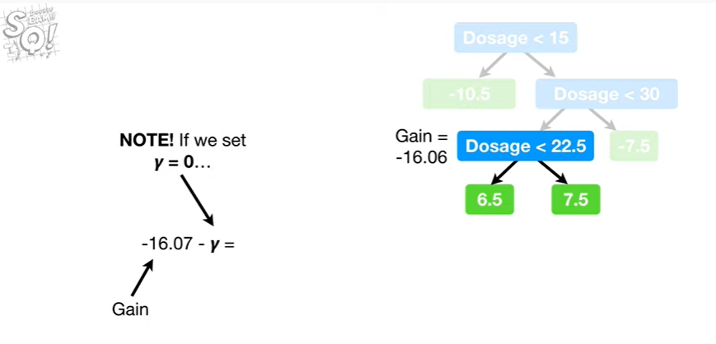

Note : if we set gamma equal to zero

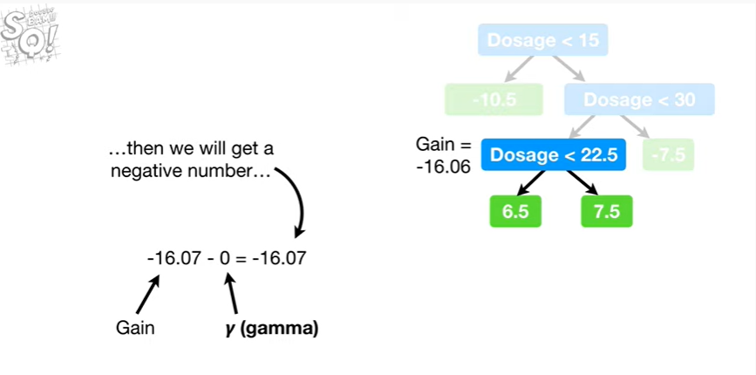

then we will get a negative number

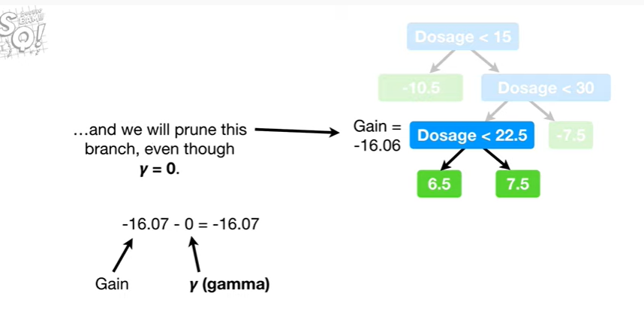

and we will prune this branch even though gamma equals zero.

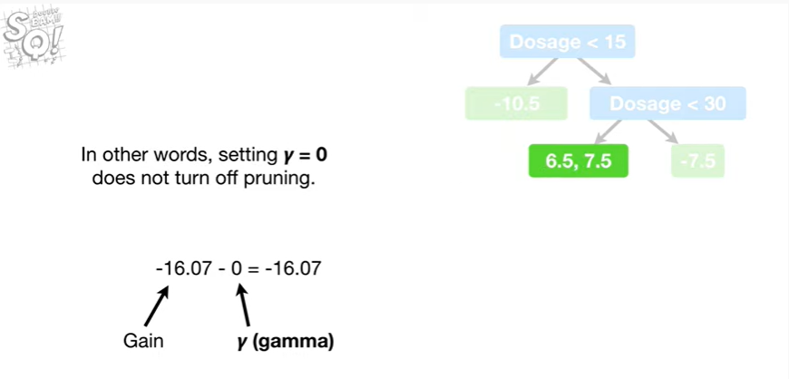

In other words, setting gamma equal to zero does not turn off pruning.

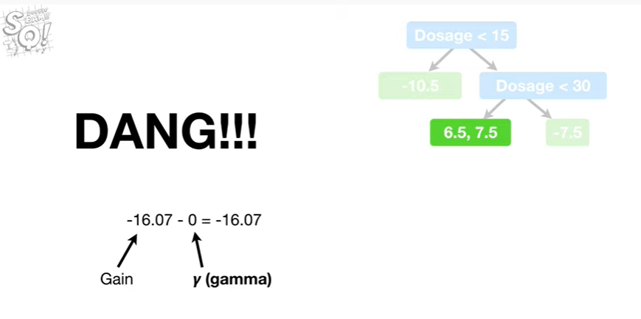

Dang !!!

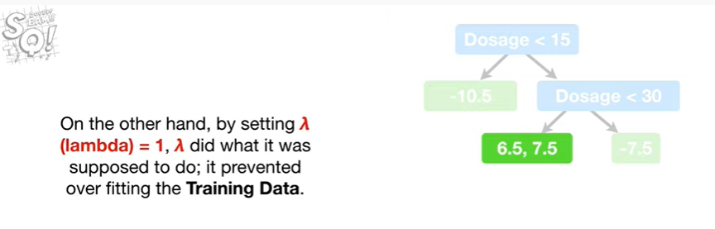

On the other hand, by setting lambda equal to 1, lambda did what he was supposed to do, it prevented overfitting the training data.

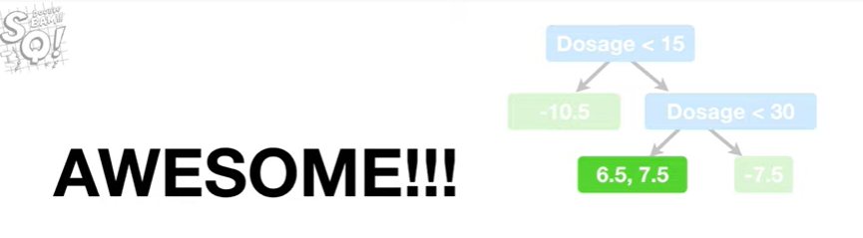

Awesome !!!

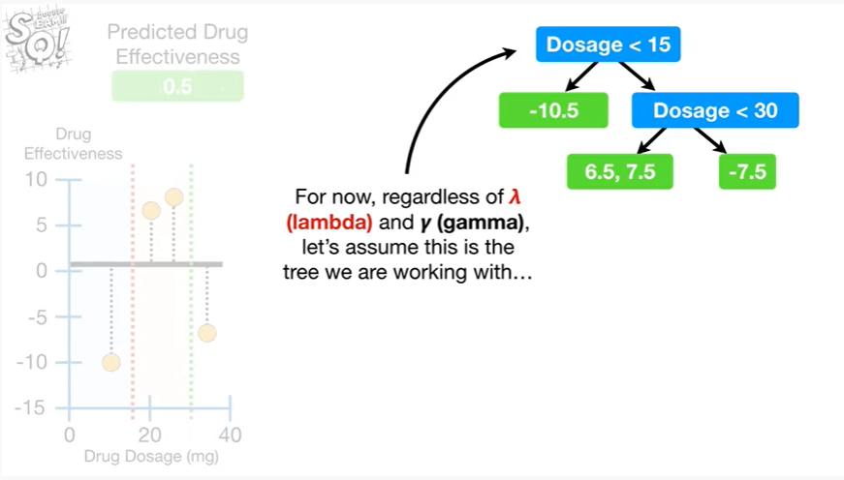

For now regardless of lambda and gamma let's assume that this is the tree we are working with

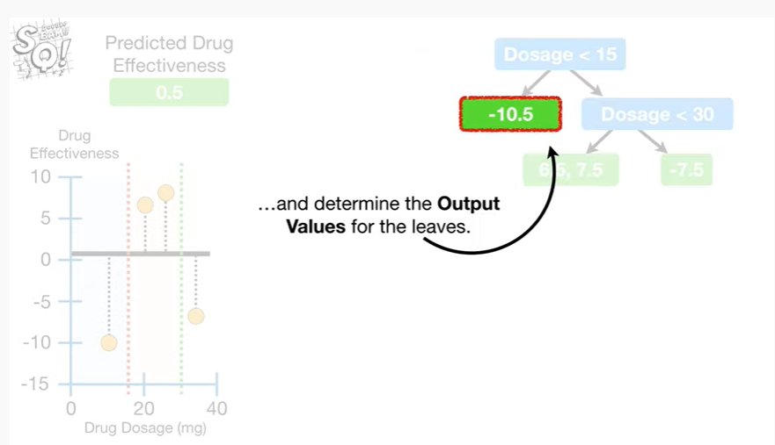

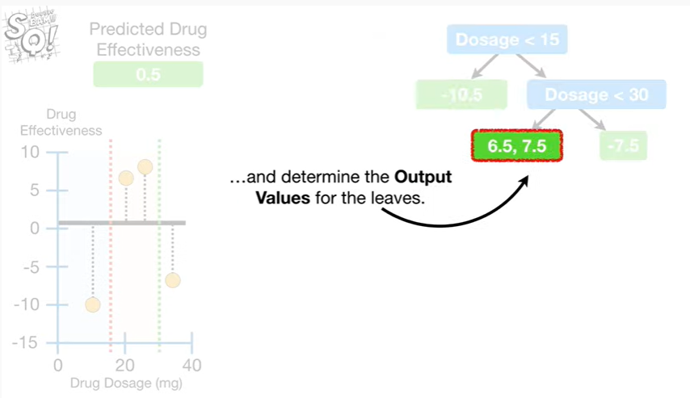

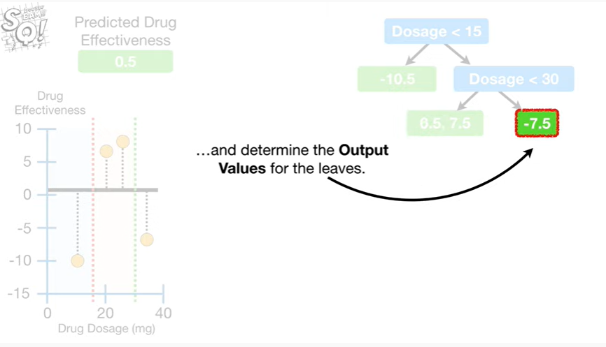

and determine the output values for the leaves.

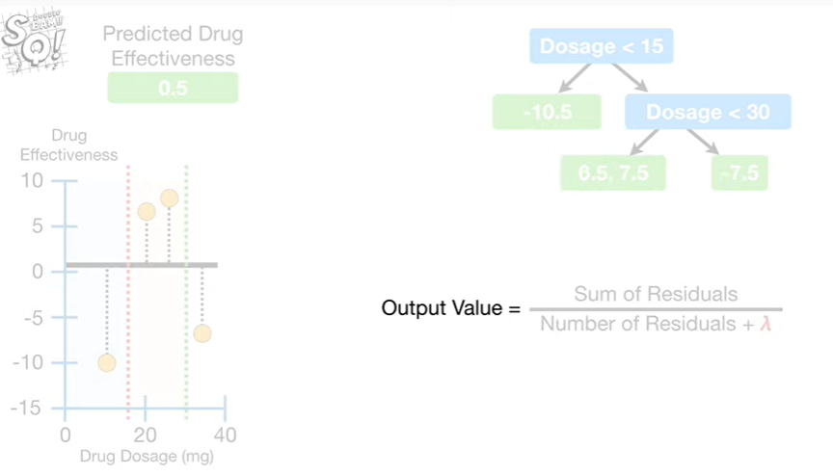

The output value equals

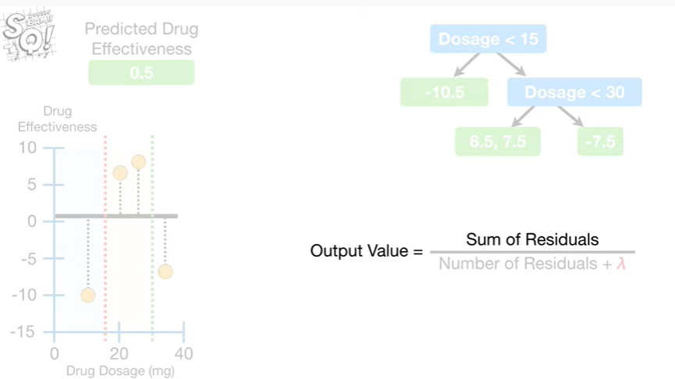

the sum of the residuals

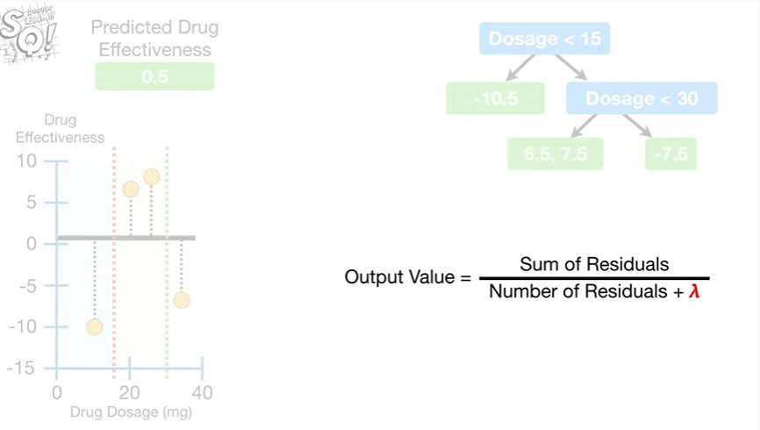

divided by the number of residuals plus lambda.

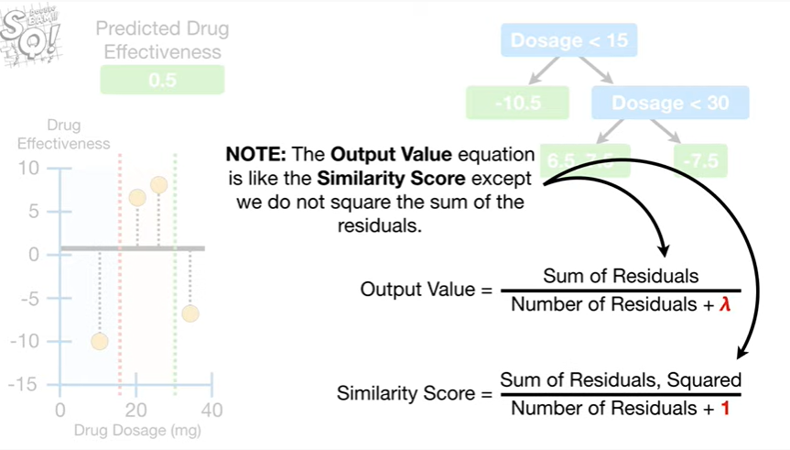

Note : the output value equation is like the similarity score except we do not square the sum of the residuals.

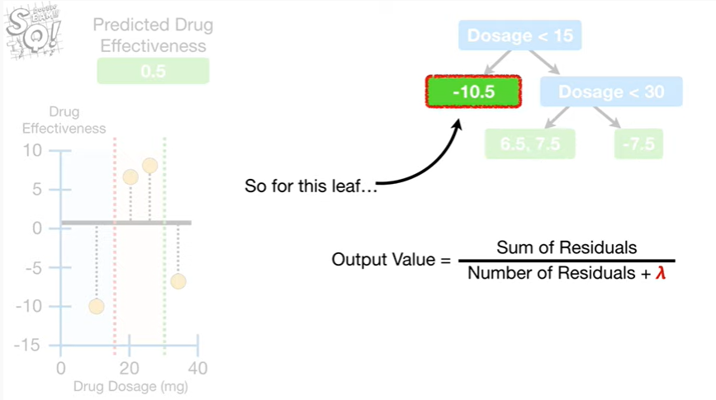

So for this leaf

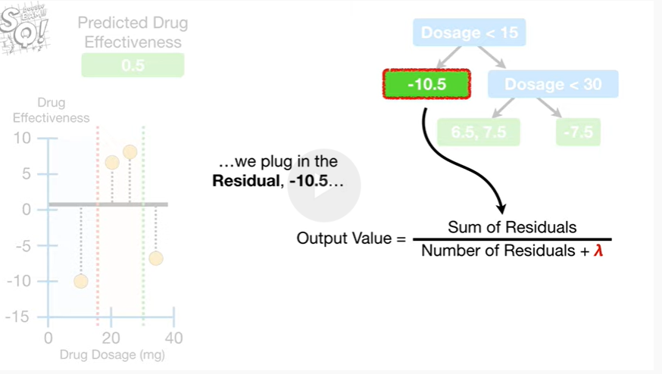

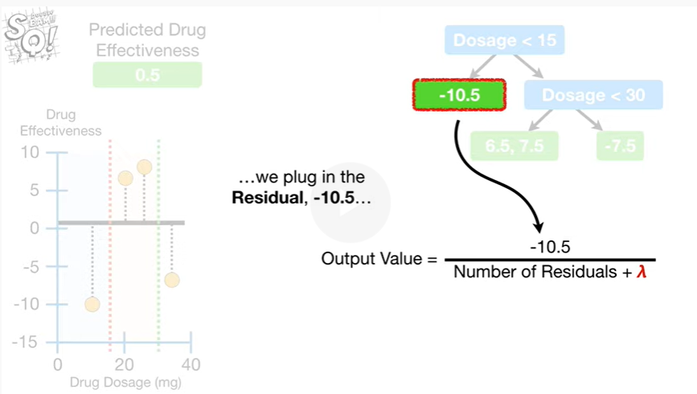

we plug in the residual negative 10.5

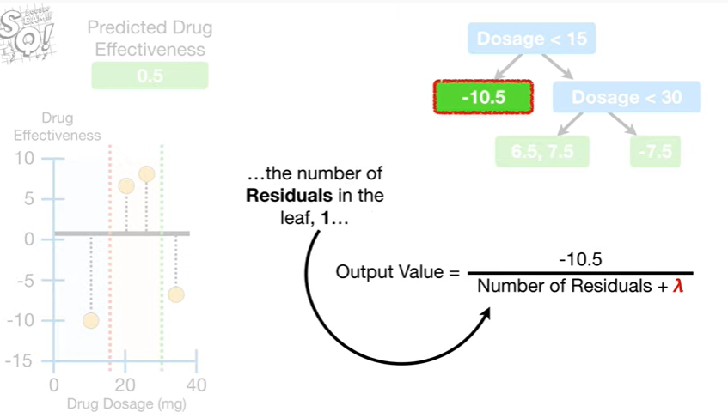

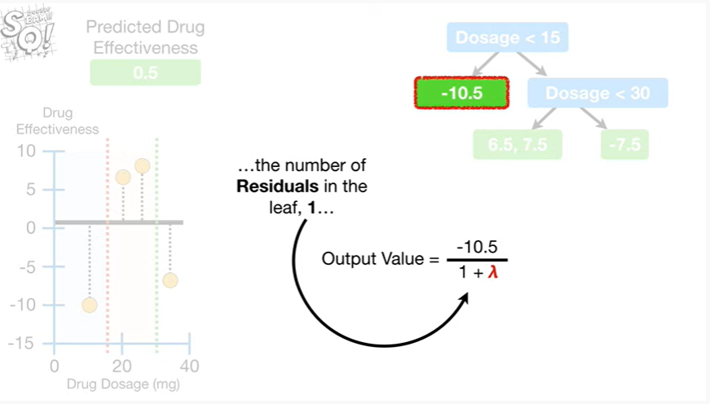

the number of residuals in the leaf 1

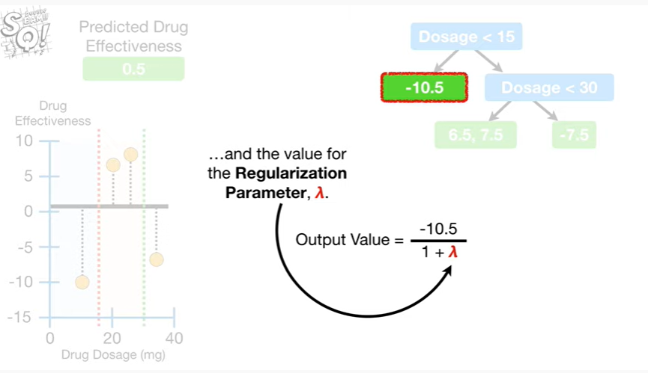

and the value for the regularization parameter lambda.

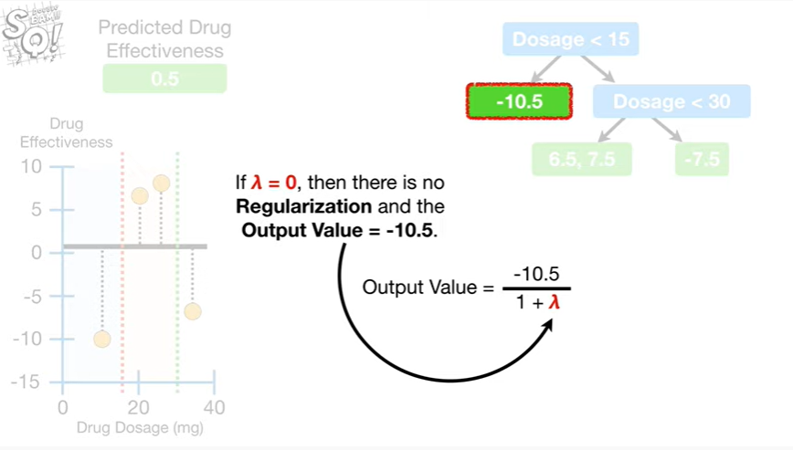

If lambda equals zero then there is no regularization

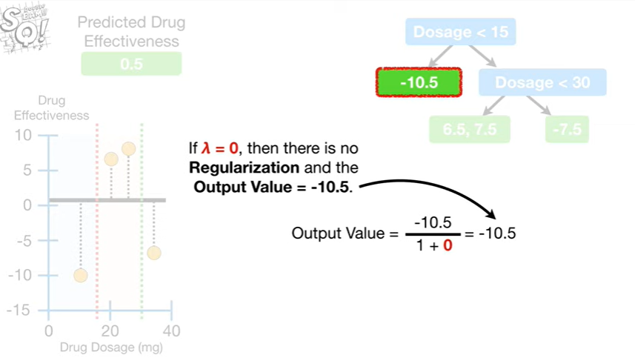

and the output value equals negative 10.5.

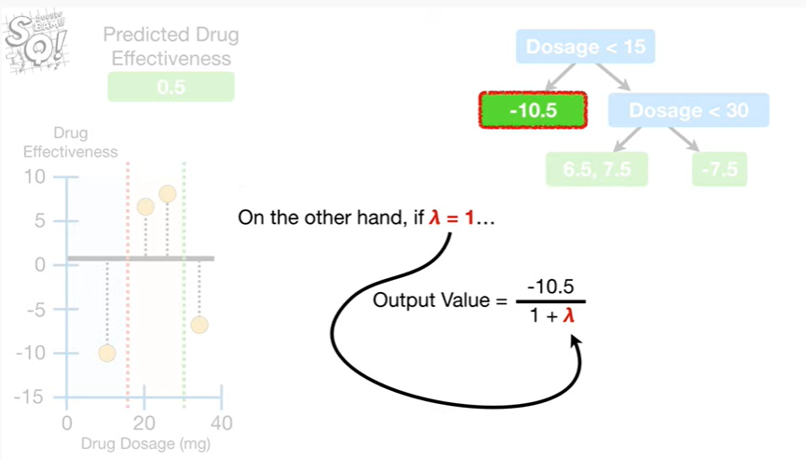

On the other hand, if lambda equals one

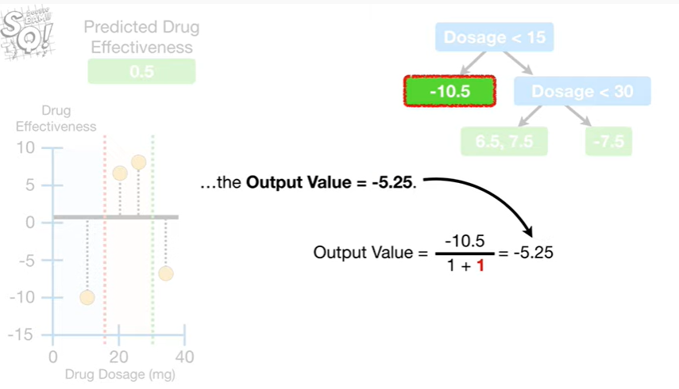

the output value equals negative five point two five.

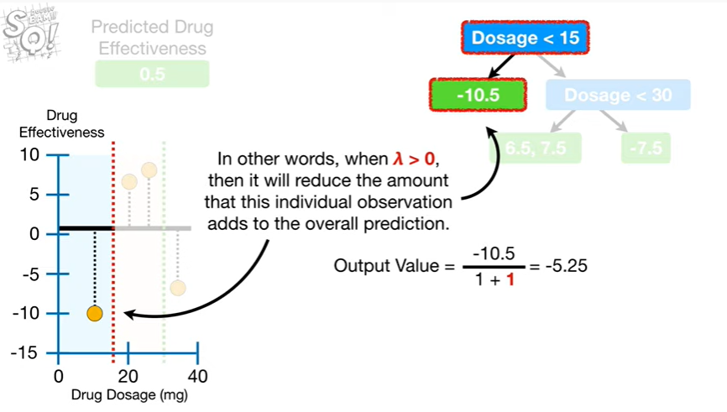

In other words, when lambda is greater than zero, then it will reduce the amount that this individual observation adds to the overall prediction.

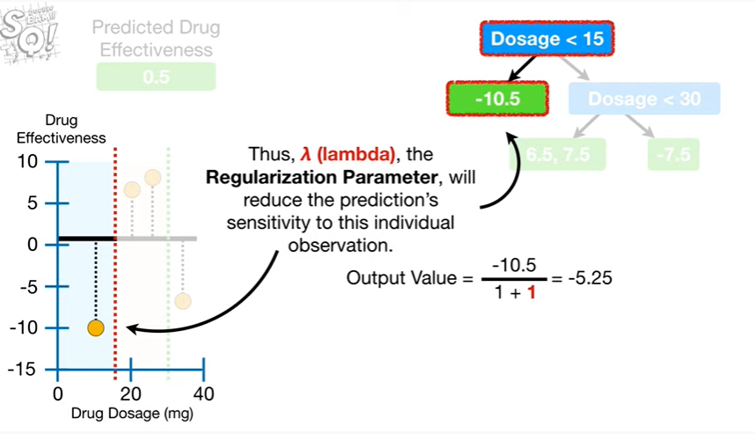

Thus, lambda the regularization parameter, will reduce the prediction sensitivity’s to this individual observation.

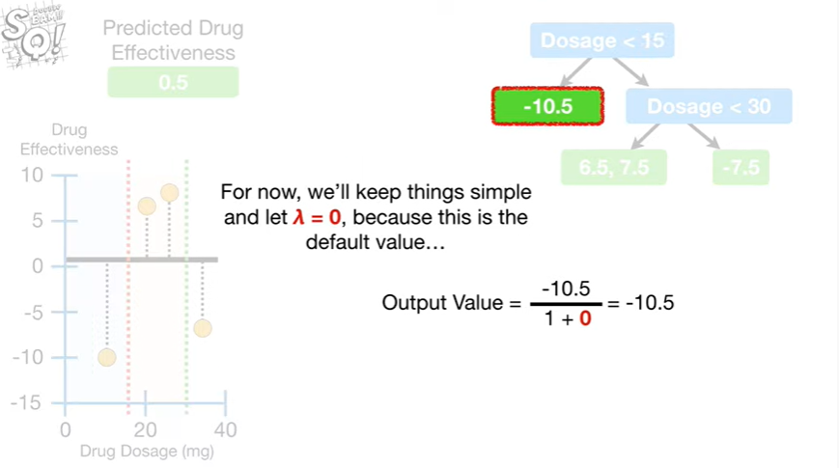

For now, we'll keep things simple and let lambda equal zero, because this is the default value

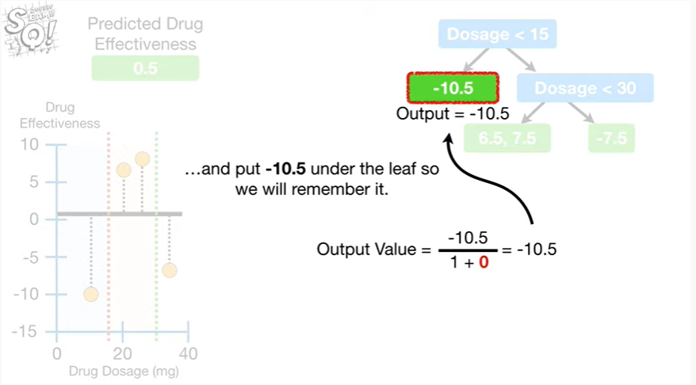

and put negative 10.5 under the leaf so we will remember it.

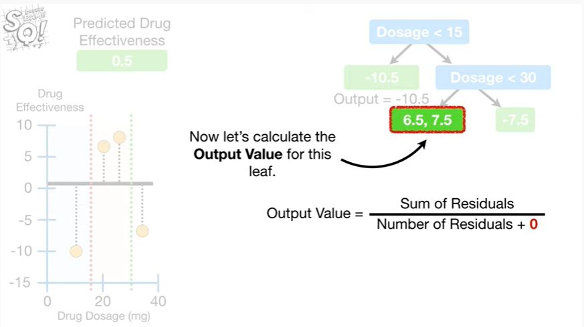

Now let's calculate the output value for this leaf

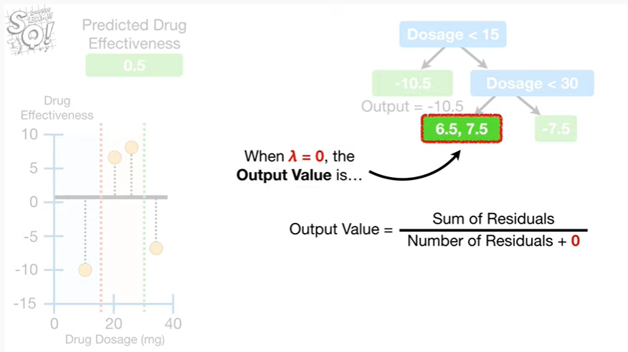

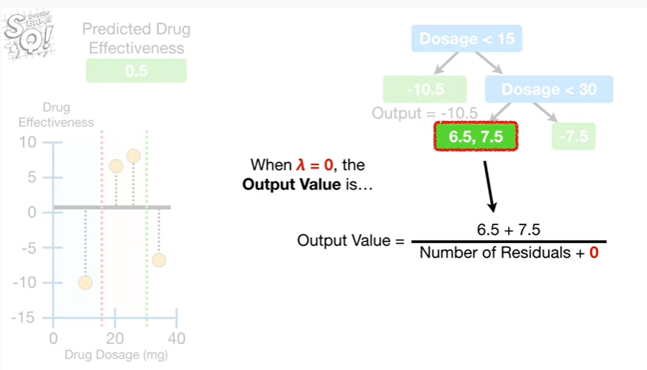

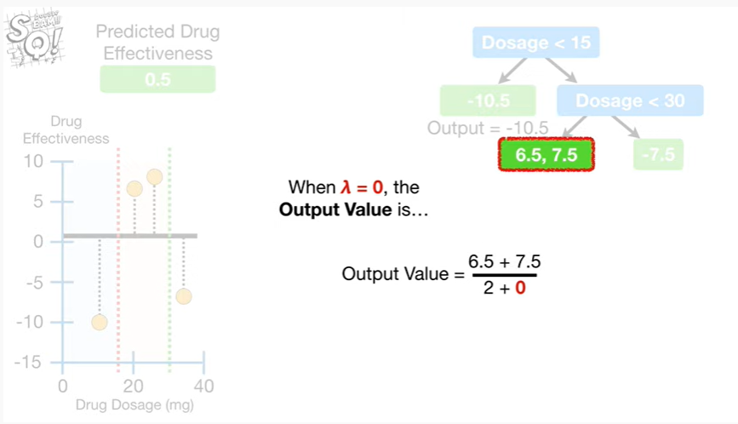

when lambda equals zero the output value is

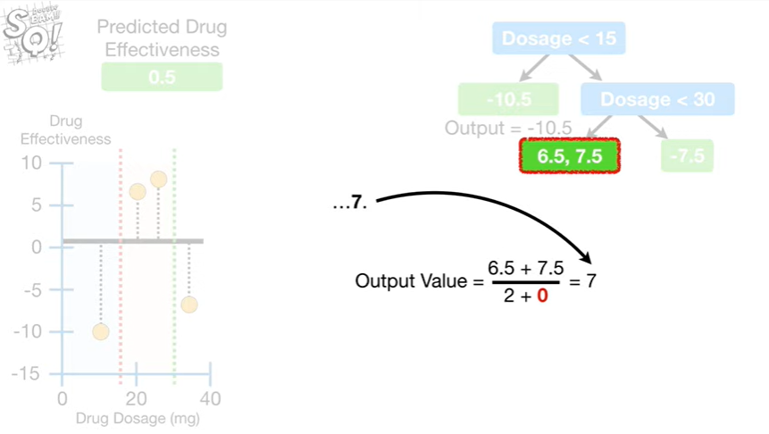

seven.

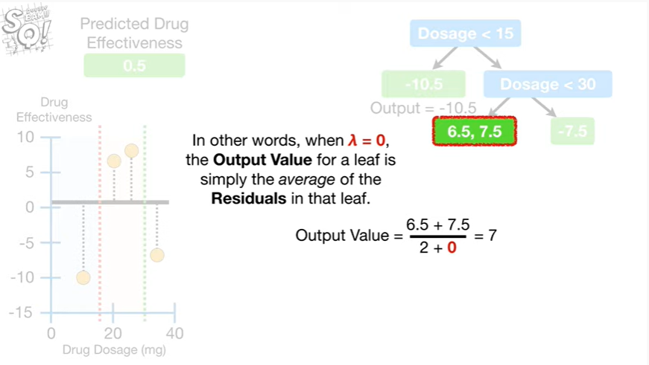

In other words, when lambda equals zero, the output value for a leaf is simply the average of the residuals in that leaf.

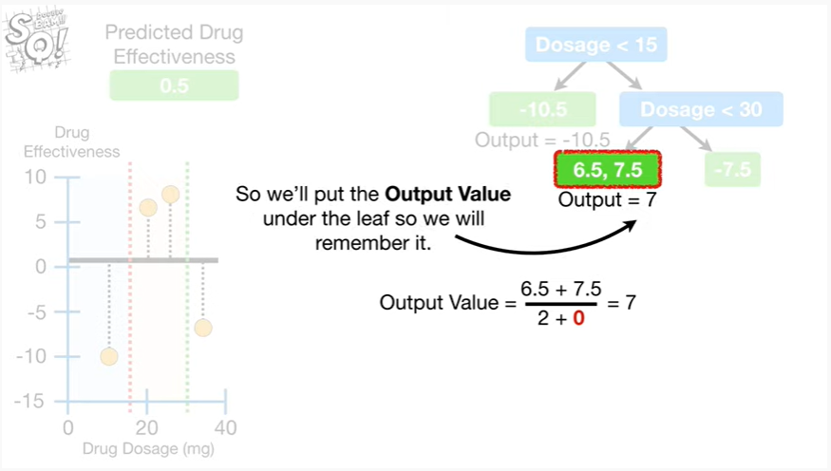

So we'll put the output value under the leaf so we will remember it.

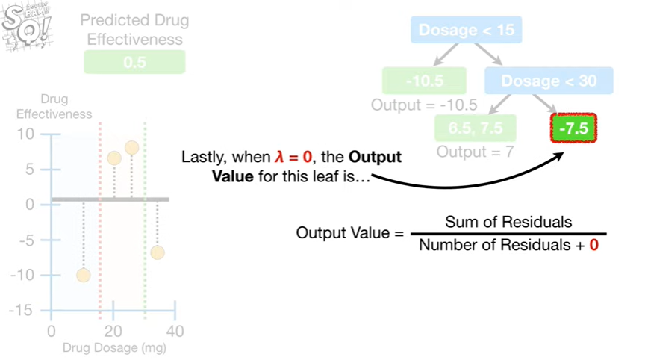

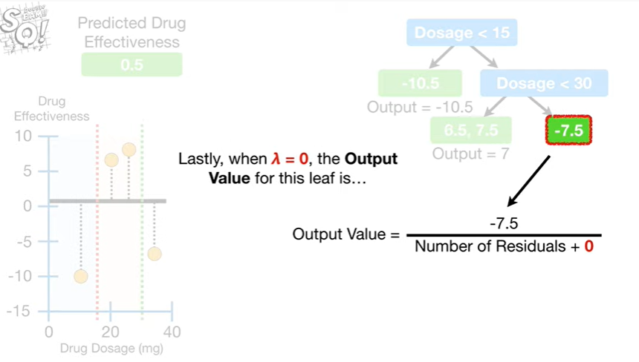

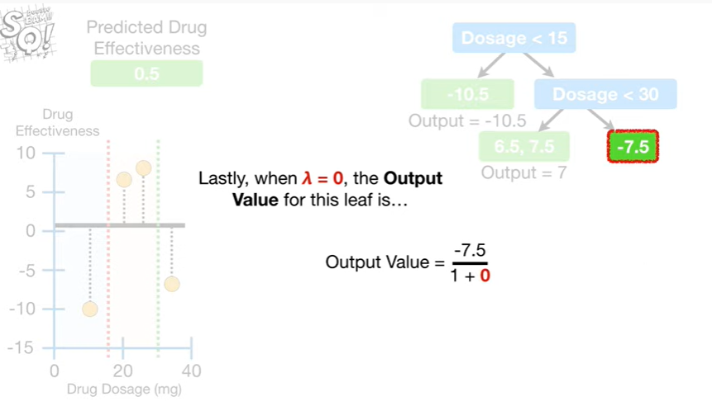

Lastly, when lambda equals zero, the output value for this leaf is

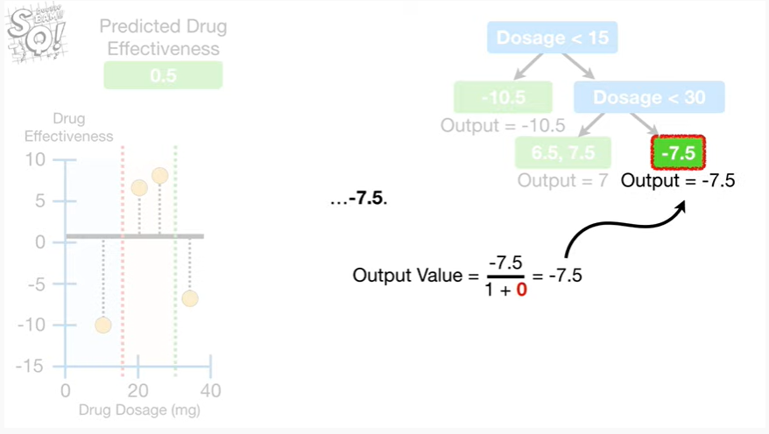

negative seven point five.

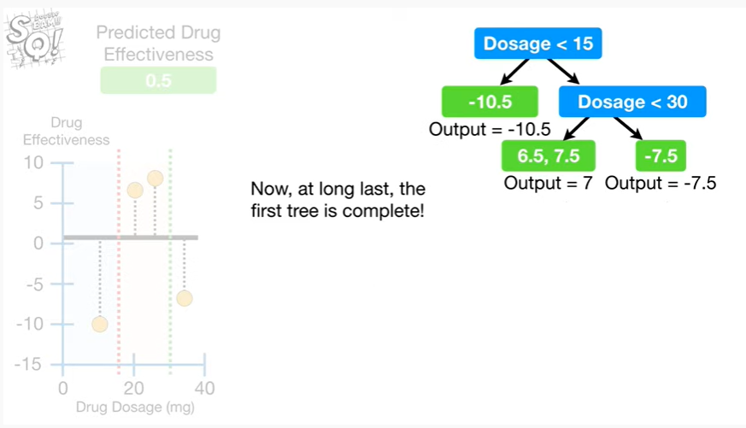

Now, at long last, the first tree is complete !

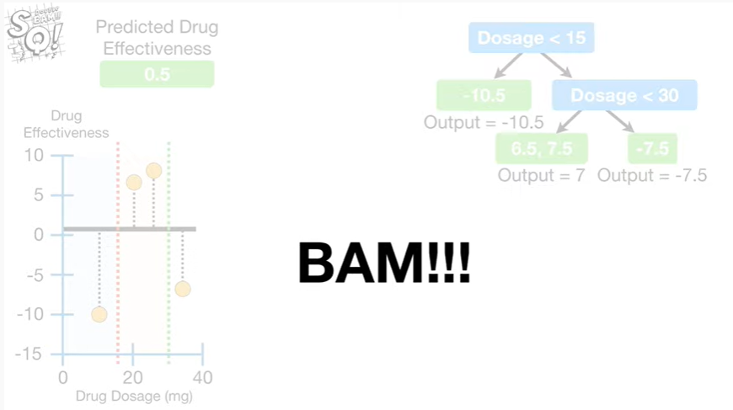

Double BAM !!!

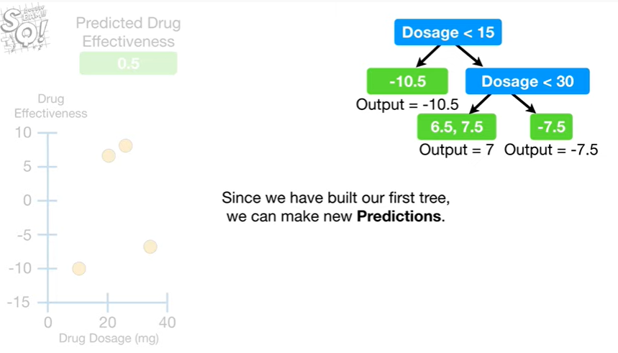

Since we have built our first tree, we can make new predictions.

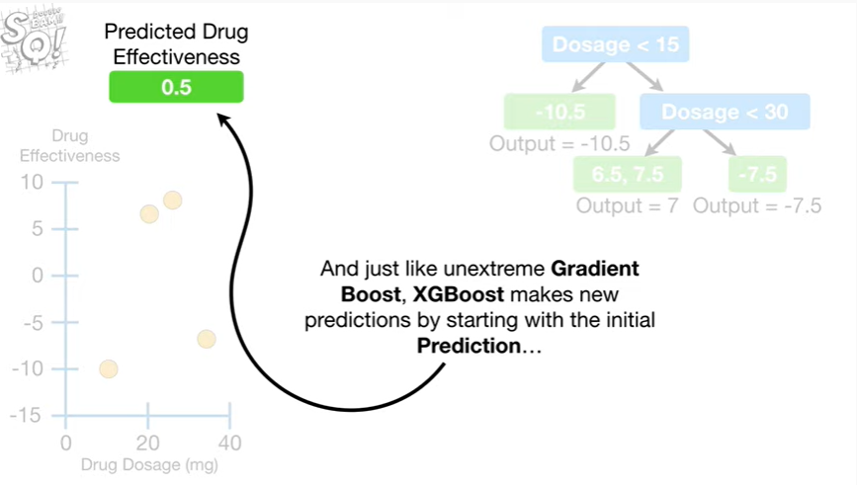

And just like unextreme gradient boost, XGBoost, makes new predictions by starting with the initial prediction

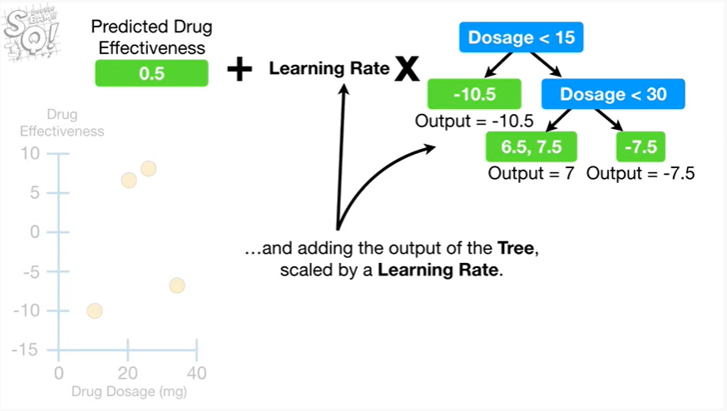

and adding the output of the tree, scaled by a learning rate.

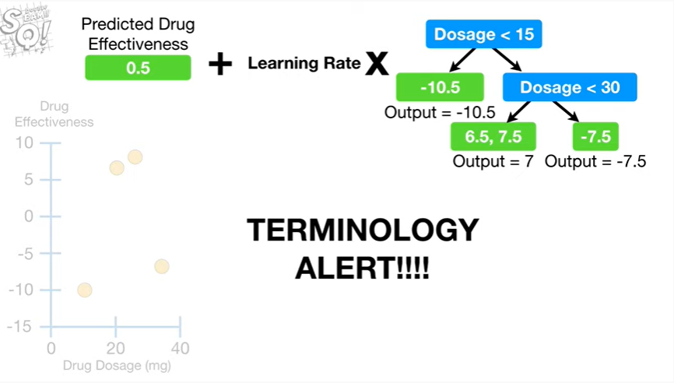

Oh no it's another dreaded terminology alert !

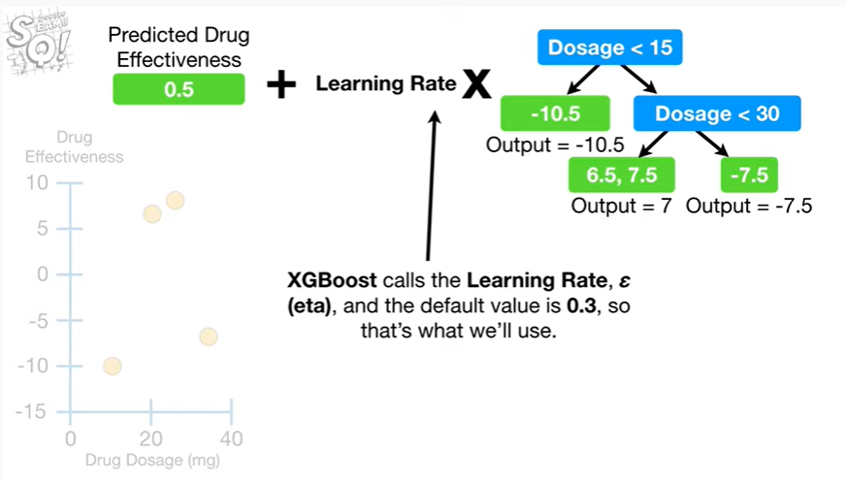

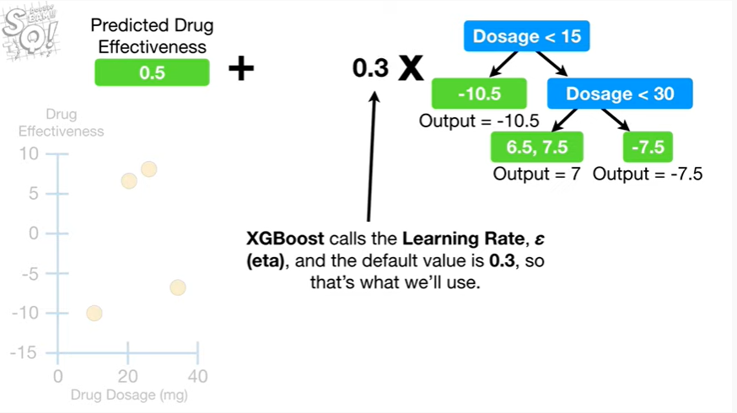

XGBoost calls the learning rate, eta, and the default value is 0.3, so that's what we'll use.

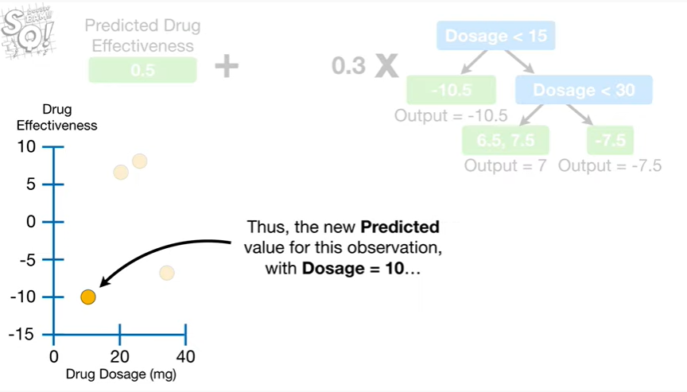

Thus, the new predicted value for this observation with dosage equal to 10

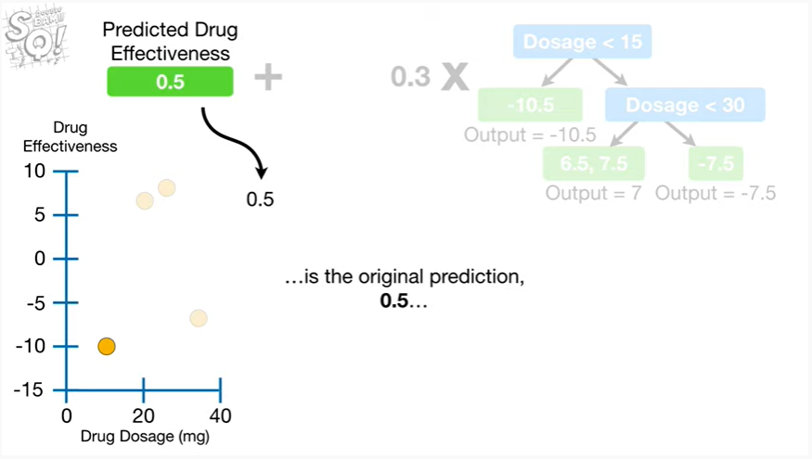

is the original prediction 0.5

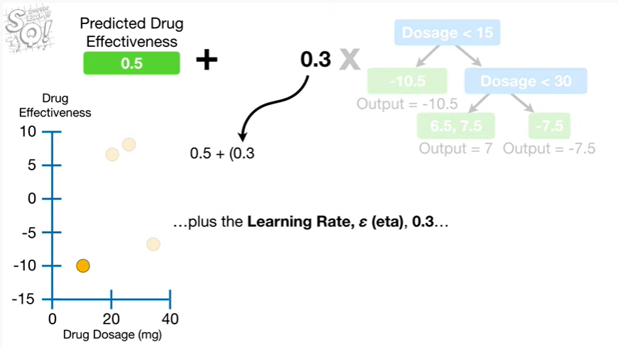

plus the learning rate Eta 0.3

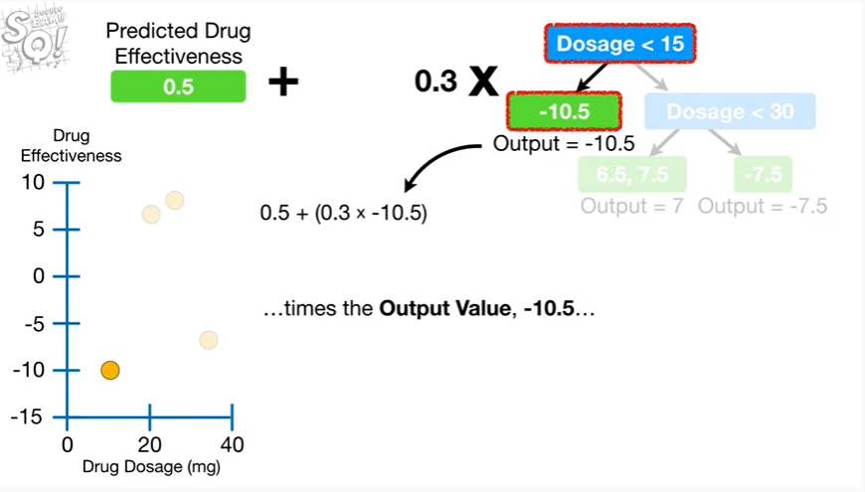

times the output value, negative 10.5

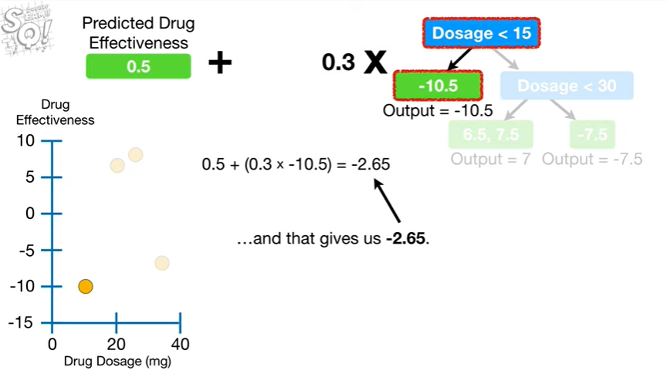

and that gives us negative 2.6 5.

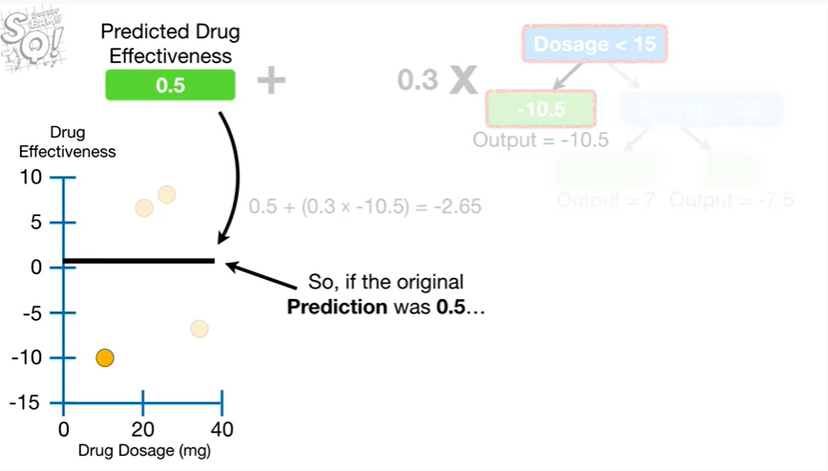

So if the original prediction was 0.5

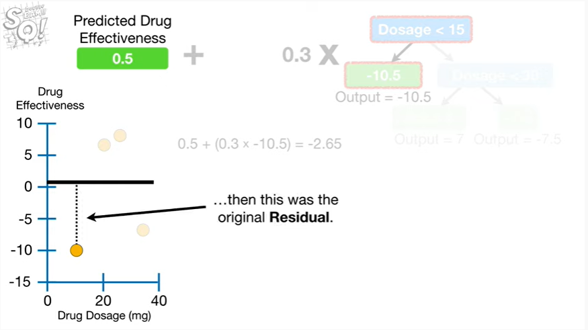

then this was the original residual.

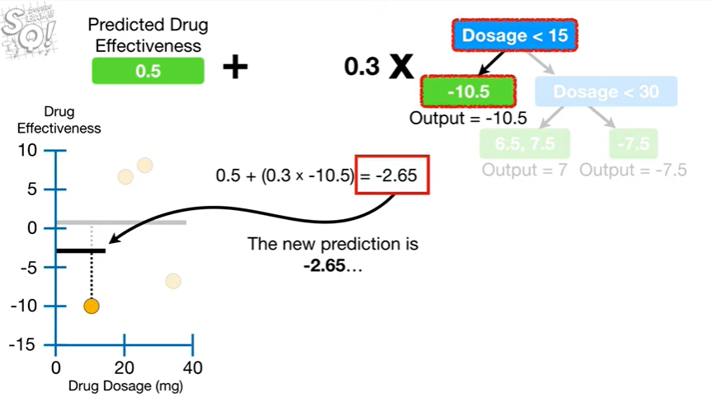

The new prediction is negative two point six five

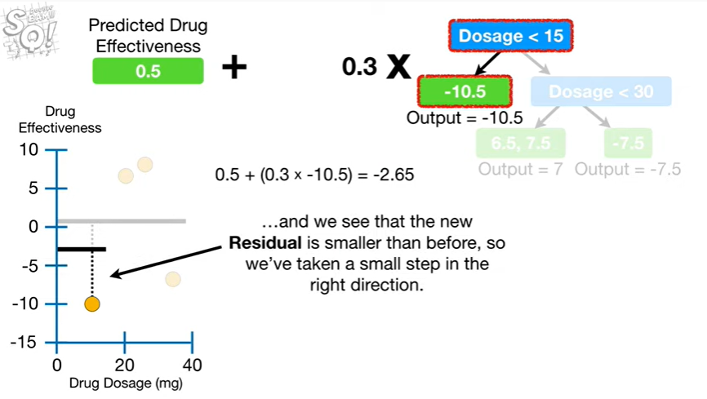

and we see that the new residual is smaller than before, so we've taken a small step in the right direction.

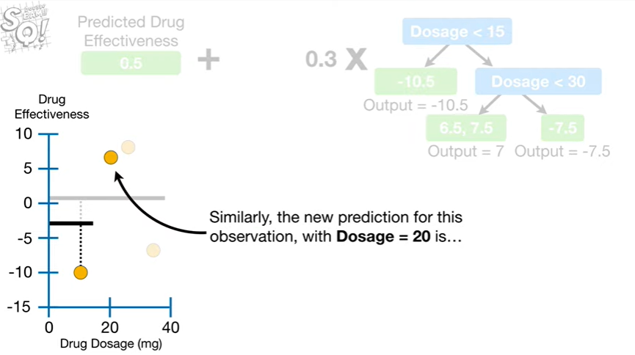

Similarly the new prediction for this observation with dosage equal twenty is

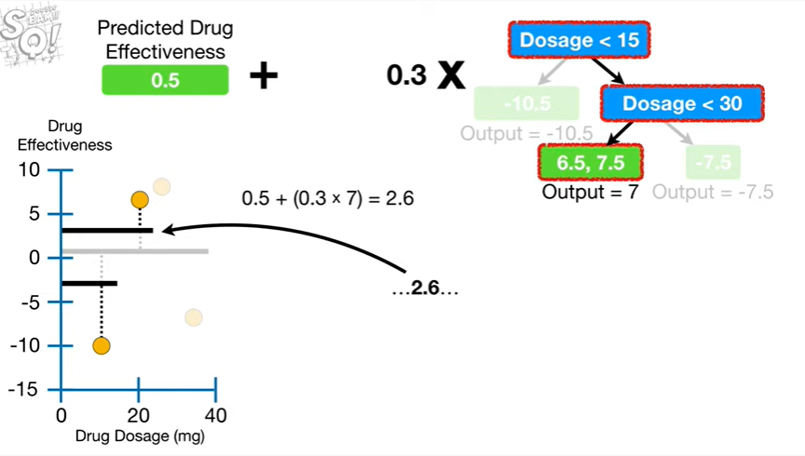

2.6

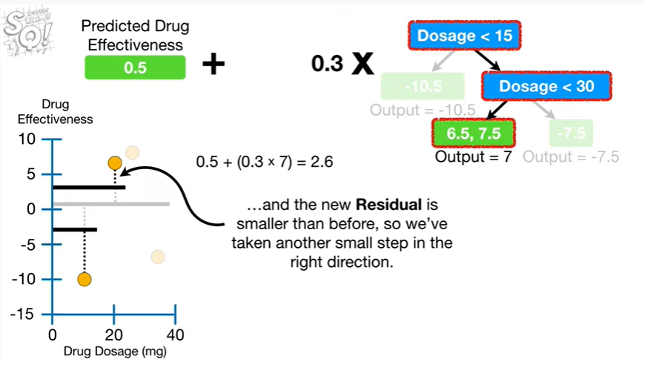

and the new residual is smaller than before, so we've taken another small step in the right direction.

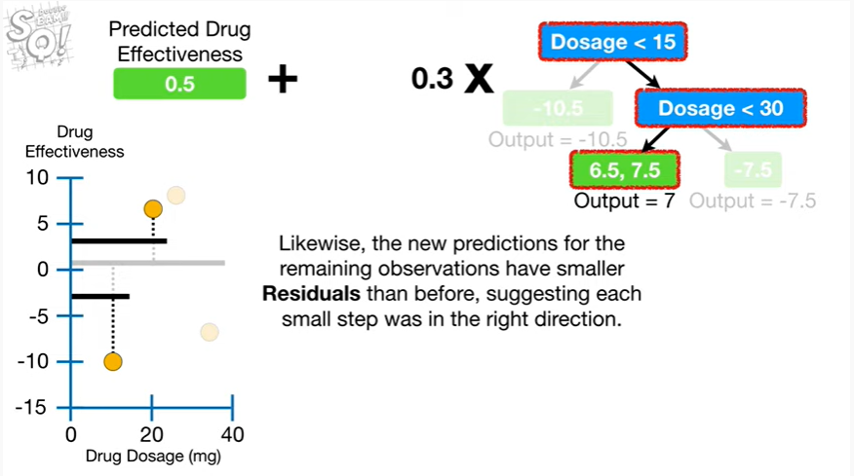

Likewise, the new predictions for the remaining observations have smaller residuals than before,

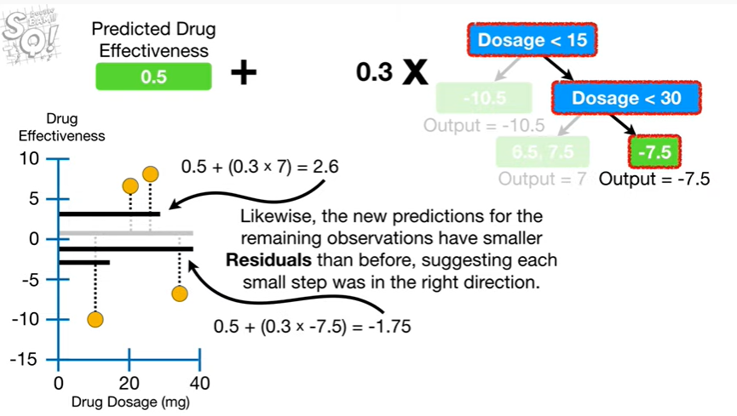

suggesting each small step was in the right direction.

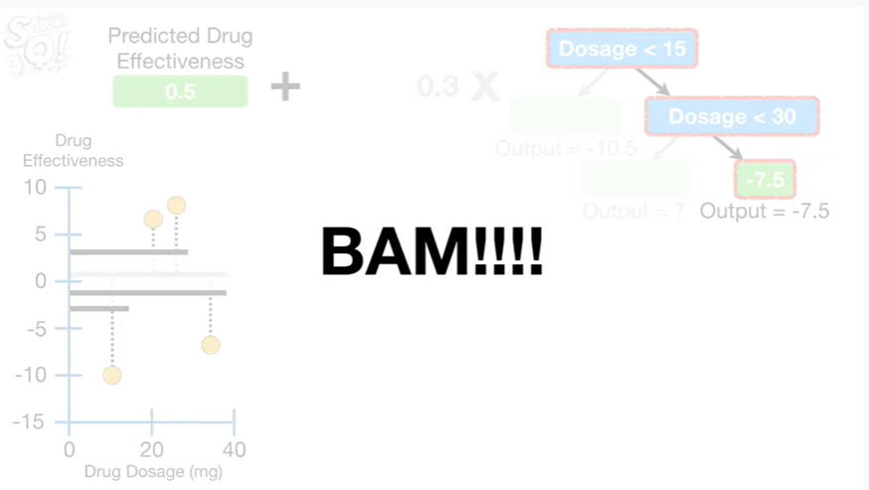

BAM !!!

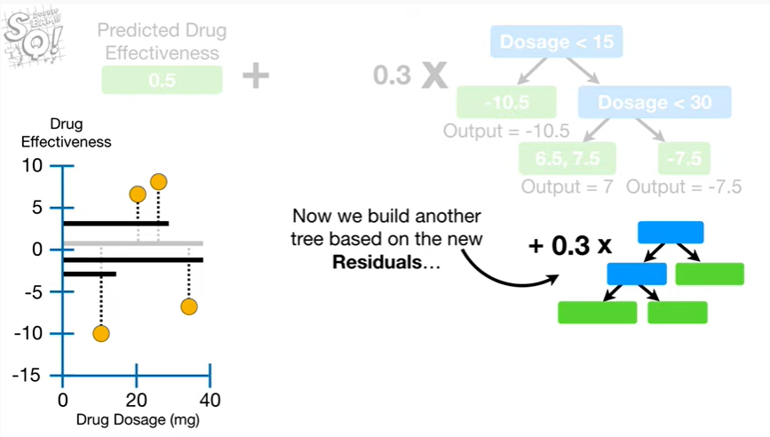

Now we build another tree based on the new residuals

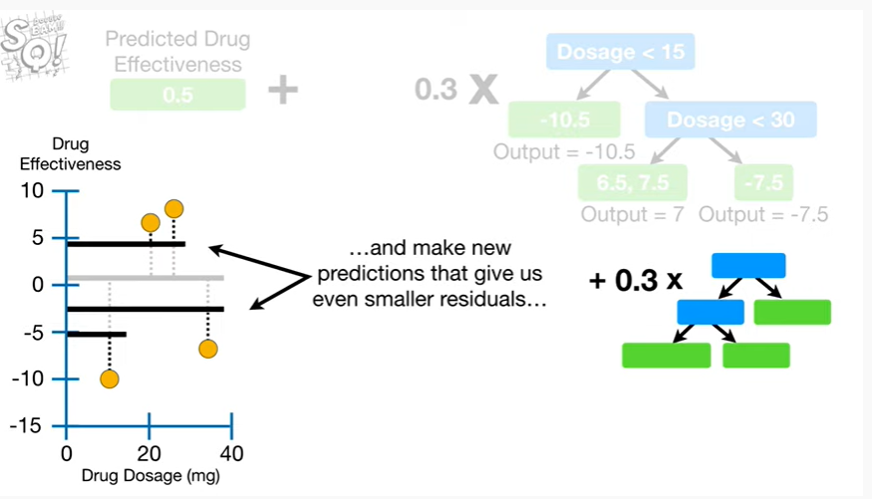

and make new predictions that give us even smaller residuals

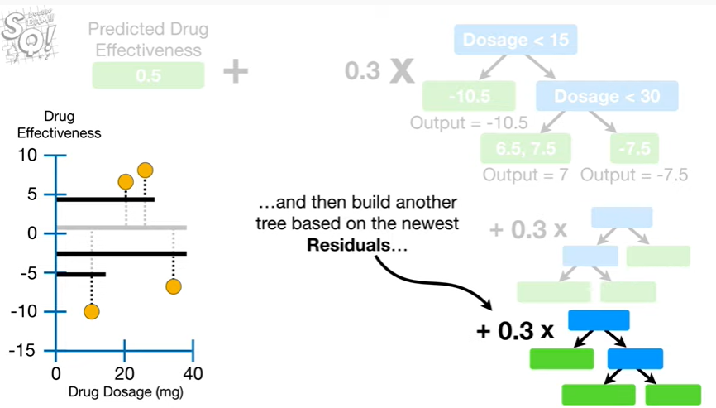

and then build another tree based on the newest residuals

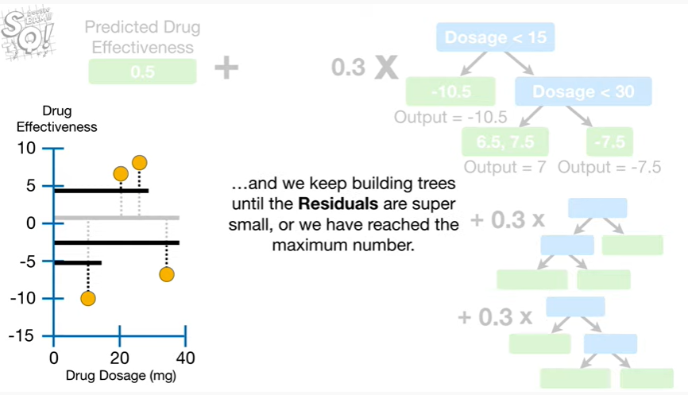

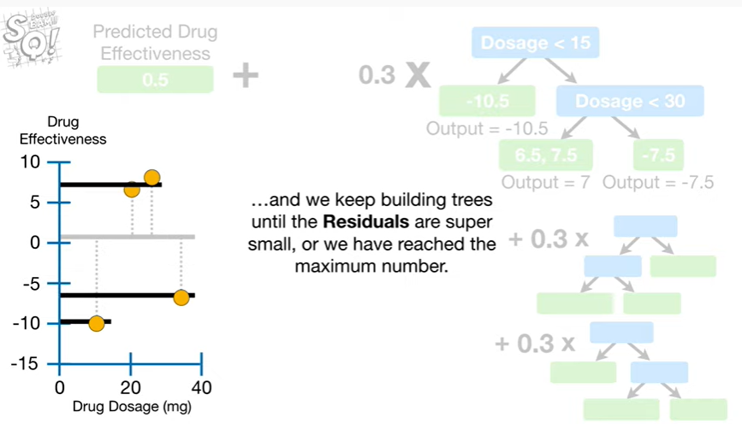

and we keep building trees until the residuals are super small or we have reached the maximum number.

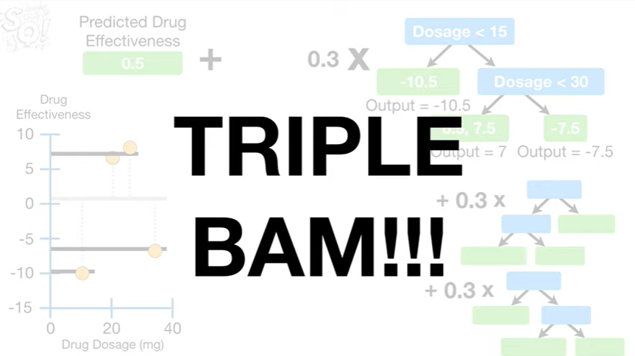

Triple bam !!!



In summary, when building XGBoost trees for regression

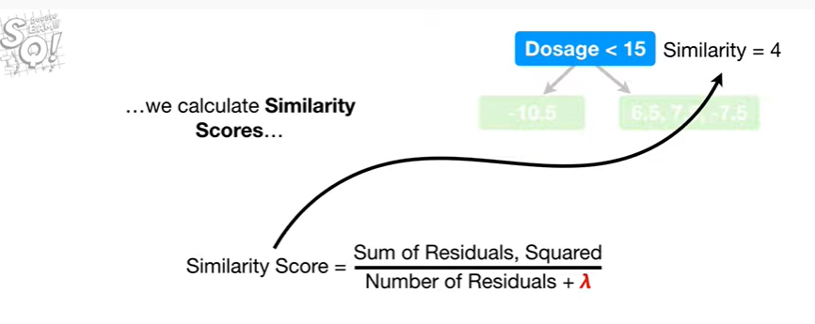

we calculate similarity scores

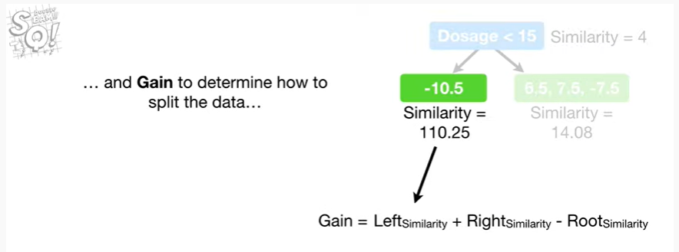

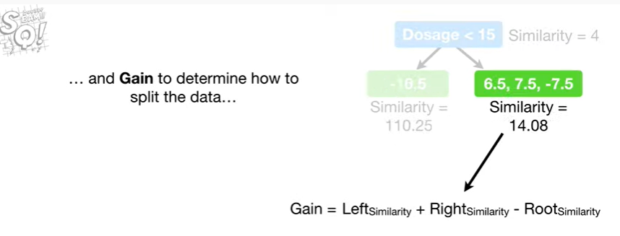

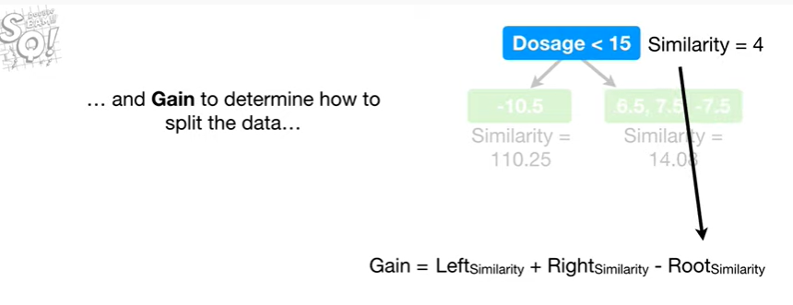

and gain to determine how to split the data

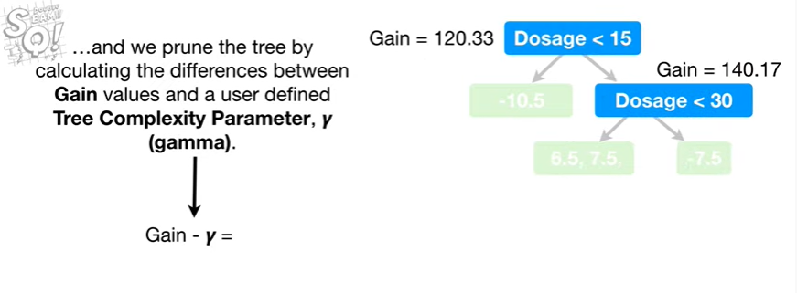

and we prune the tree by calculating the differences between gain values and a user defined a tree complexity parameter gamma.

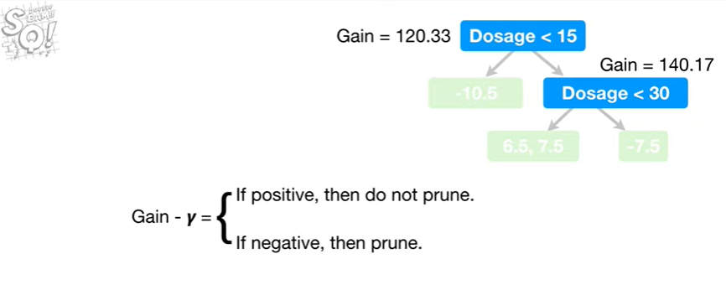

If the difference is positive then we do not prune.

If it's negative then we prune.

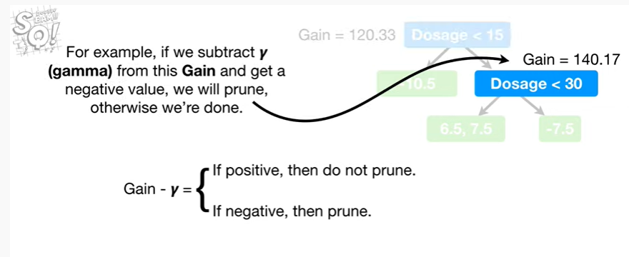

For example, if we subtract gam off from this game and get a negative value, we will prune, otherwise we’re done.

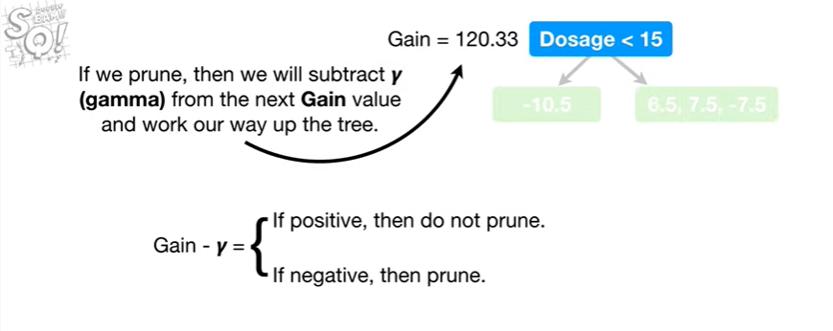

If we prune then we will subtract gamma from the next game value and work our way up the tree.

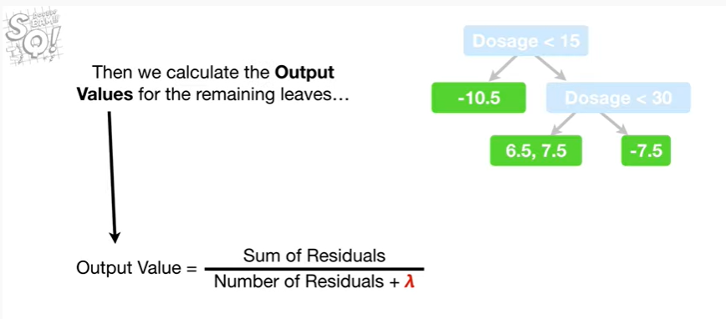

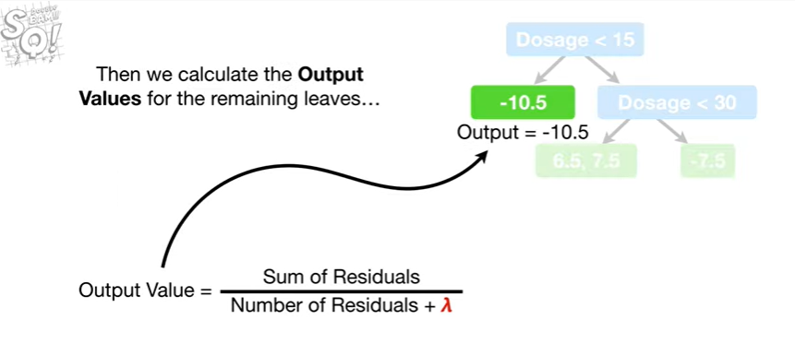

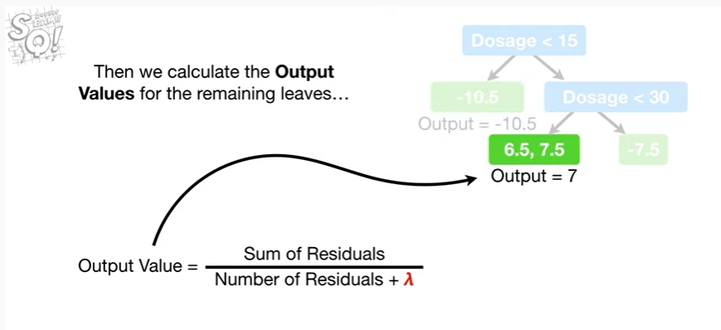

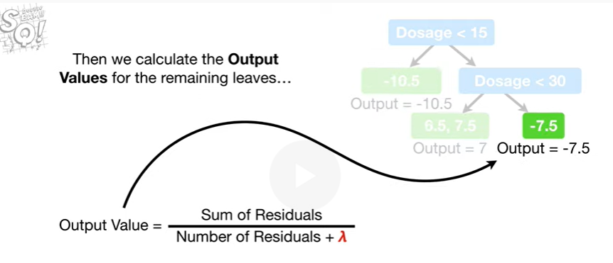

Then we calculate the output values for the remaining leaves

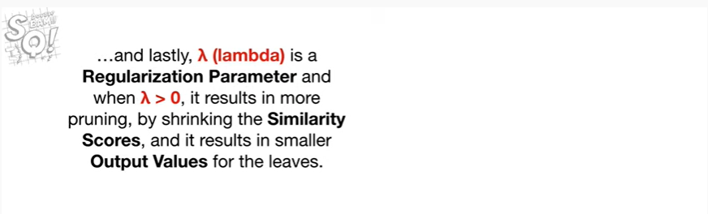

and lastly lambda is a regularization parameter and when lambda is greater than zero, it results in more pruning

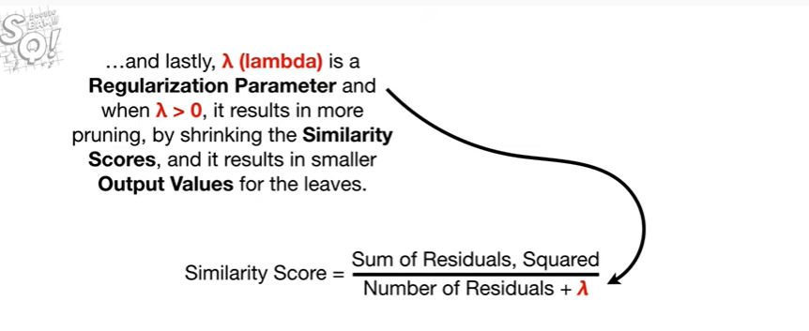

by shrinking the similarity scores

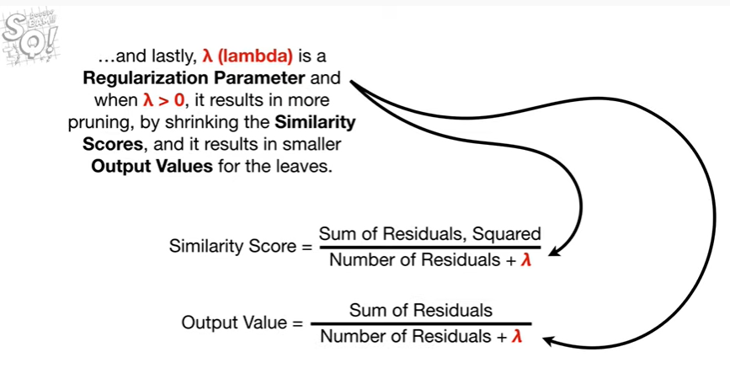

and it results in smaller output values for the leaves.

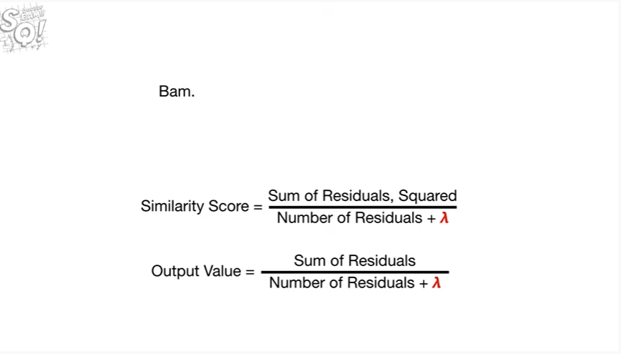

BAM.



Tune in next time, for XGBoost part 2, when we give an overview of how XGBoost trees are built for classification.

It's going to be totally awesome !!!